A report on

Global strategy

Student Name:
ID:

Table of Contents
- Introduction 3
- Overview and purposes of SEVEN 4
  - The vision of SEVEN 4
  - Core values of SEVEN 5
  - Affordable phones for everyone: 5
  - The target of SEVEN 6
- Country-wise discussion of strategies 7
  - Netherland 7
  - Belgium 8
- Strategic analysis 9
  - SWOT analysis 9
  - Generic strategies 12
  - Growth strategy 13
- Discussing the choice of the Netherlands and Belgium over territories 15
  - Discussing the consequences of choosing the Netherlands over other countries 15
- Discussing the reason for investment in specific functions 16
- Explaining why investment will impact positive or negative growth 18
  - Analysing how choices and strategies created value 19
  - Critical use of theoretical insights and analytical frameworks to assess strategic, competitive and performance implication 19
- Conclusion 20
- References 21

Introduction
Action plans designed for companies to compete in the foreign market with core strategies and the beacon of hope to stretch business arena and thereby boost yielding is referred to as global strategy. There exists an unprecedented challenge between the key market players regarding the cost minimisation, productivity enhancement, accelerating sales and finally technological elevation. Identifying a financially booming market and exploring those with competent strategies is the foremost objective of global expansion strategies. Since its inception in 2018, SEVEN has been manufacturing smartphones with using lean production system and total quality management (TQM) approaches. Discernibly, the company is intended to develop market into the Netherlands and Belgium, apart from growing in its existing market in the UK, by pursuing cost leadership approach rather than product leadership or customer intimacy. Besides, the company shoots for attaining €5,900,000 bottom-line from its currently losing position and desires to secure a 12% return on equity (ROE) as its KPI. Not least, the company is intended to dominate 24% and 26% market share respectively in both the Netherlands and Belgium market.

Overview and purposes of SEVEN
The emerging smartphone manufacturing giant, SEVEN with the punchline ‘Meet the New World’, is ensuring a standard quality handset device within the most affordable price in the UK telecommunication market. By leveraging the core competencies and exceptionally supreme expertise, the maestro company has been intended to explore the Netherlands and Belgium telecommunication market. Bradley (2019, p.164) has stated that the Finance Manager will carry out the capital budgeting analysis to find out the investment feasibility of €768 billion in the Netherlands (Bradley, 2019). Besides, he reserves the responsibility to monitor and control the variances after analysing each cost heads. Interestingly, the Netherlands can be the next massive production hub for the company as its only 1/3rd of the labour cost in the UK (Top 6 Benefits of Doing Business in the United Kingdom, 2020). Moreover, the geographical positioning of the Netherlands is suitable enough to render production cost to the minimum level. As herein depicted the distribution cost of different geographical areas-
Geographical areas | Production cost | Distribution cost | Total cost | Ranking
The Netherlands | €765 billion | €125 billion | €890 billion | 1st
China | €385 billion | €696 billion | €1081 billion | 3rd
Belgium | €685 billion | €225 billion | €910 billion | 2nd

The above analysis shows that the Netherlands will be the most feasible to commence manufacturing with a production and distribution cost of €890 billion only.

The vision of SEVEN
Vision statement as stated in the company’s manifesto is ‘Meet the New World’ which is a seismic one in the entire telecommunication market in Europe due to its general offer to the mass people of opting an affordable and technologically advanced handset. By pursuing this strategy SEVEN can grab 45% more sales in the Netherlands and 23% more in Belgium than UK sales. The company boasts over its core competencies and long-term expertise in producing smartphones.

Core values of SEVEN
SEVEN has built at its foundation 3 core values upon which the entire operation is carried on-
Connecting the world: To expedite the influx of information at an unprecedented level from one pole to another, the telecommunication company has been engaging seismic research activities to reduce the connecting time. It has even been able to reduce the accessibility lag for the end-users by 12% and thereby mitigated the connection setup time by 0.034 nanoseconds. SEVEN believes that people should get connected at any time to any furthest point of the planet uninterruptedly and instantly. Thus, it is purveying UK’s fastest customer interface which remains unbeatable by its competitors.
7 billion phones for 7 billion people: The domineering telecommunication company has been desiring to enter massive production so that it can serve the entire world community with its latest technological amelioration. No matter which corner of the world a person may reside, SEVEN visualise itself at his doorstep within 2030. The company intends to bring the technological beacon at everyone's fist with such a graphical user interface (GUI) so that they can have a superior user experience.
Affordable phones for everyone: People with any level of income can opt for SEVEN phones and with this appreciation in mind it has built a lean and rationalised production systems to bring handsets at the very reach of mankind (Andersen, 2020). It has even built manufacturing units where labour and distribution cost is the minimum.

The target of SEVEN
SEVEN has furnished targets based on its company-wide key performance indicators (KPI) which the company wants to pursue within 2023. There are certain financial and non-financial KPIs as determined by the directors which are depicted herein-
Particulars | Break down | Cal. | Comment
Profit acceleration target | (5,900,000 + 60,131,412.63) / 60,131,412 | 110% | Profitability is the prime KPI as the company is sustaining a loss.
Return on Equity | 5,900,000 / (250,000+512,250,000-60,444,413) | 1.31% | It refers to that profitability should be enhanced so that the investment in equity becomes viable.
Average receivables days | 16,992,000 / 189,966,600 * 365 | 32.65 | Alluring credit terms can be offered such as 5% discount if paid within 15 days.
Interest to debt ratio | 180,000 / 7,000,000 | 2.6% | Debt financing may be enhanced so that ROE boosts up to 1.305%.

The above calculation shows that the company must strive hard to bring about profitability form its existing loss generating position. It must introduce lean manufacturing system through which it can assess and eliminate the unwanted loopholes and deficiencies in the production process (Andersen, 2020). Moreover, it needs to grab market shares of 21% in the prevailing UK telecommunication sector. Nevertheless, it can increase debt financing to power up ROE percentage. The company is experiencing adequate working capital to finance its regular activities.
Certain non-financial factors impact massively on SEVEN dues to its profound operation in a complex business environment. The successive table illustrates such factors and target of the company in this regard-

Non-financial factors | Targets
Suppliers are asking for the price increase | Find an alternate supplier or commence in-house production (Rejda e al., 2020).
Regulatory violation and penalties | Check and update to make sure that no such thing occurs.
Delivery van accident cases | Appoint shrewd and expert drivers (Dyer, 2018).

Country-wise discussion of strategies
Netherland
Netherland is a small country in Europe, but it is an exporting country of Agro-products in the world market which makes its economy rich. Considering the Gross Domestic Product (GDP), the economy of the Netherlands is ranked as the 17th in the world and 8th among 45 countries in the European region. Its GDP growth is 2.6 % and its per capita income is estimated at around £30,000 (World Bank, 2020). Netherland is considered as the sixth largest economic power in Europe. However recently, the economy is suffering heavily due to Covid-19 pandemic. Still, there is a great scope of marketing of SEVEN in Netherland due to its buoyant economic condition. The Mobile SEVEN Company should adopt different marketing attractive policies such as the offering of lowest price, long guarantee for the device, after-sale services, discounts to the customer and other marketing policies as and when deem fit to flourish their marketing of products in the Netherland market. The Market share is expected to be 24% and sales are expected to be around 765,988 units by the end of 2025. Because it is a great opportunity for the mobile company to penetrate the Netherland Market since the economy of the country is growing and due to the following favourable factors:
Warehouse Capacity: 10000 Handsets
Agreement Term of Rent: 1 year
Cost without discount: € 460,000.00
Belgium
Belgium is dependent on service and industry and enjoying a unique position in the European Economy. Its economy mainly relies on the export of goods to the international market and major portion of GNP comprises of export income (World Bank, 2020). Belgium is a politically stable and a developing country. Its economy is growing faster. It has been ranked 26th in respect of GDP in the whole of Europe and 18th in respect of Per Capita Income (Belgium Economic Snapshot - OECD, 2020). The country is safe for Foreign Investing because there is an ample scope to invest in the industrial sector due to its industrial hub. But recent Covid-19 pandemic has affected the economy adversely but still after the recent pandemic phenomena, the potentiality of marketing campaigns of SEVEN in Belgium is high, considering the Economic Growth and per capita income of the inhabitants of the country (Belgium Economic Snapshot - OECD, 2020). SEVEN can easily penetrate the market by offering lucrative packages to the customers such as handsets having different designs and colours, the lowest price for the product, after-sales services and so on. Mobile SEVEN can earn 8% of market share here and 456,988-unit sales by 2025 in the Belgium market due to its following favourable factors:
Warehouse Capacity: 8,000 Handsets
Agreement Tenure: 2 Years
Cost after discount: € 345,000
Discount based on Agreement Tenure: 0%

Strategic analysis
To meet company goals SEVEN needs to analyse the current and future strategic position of the company considering both internal and external factors. The management of SEVEN can apply some strategic framework that is discussed below:

SWOT analysis
Using SWOT analysis management will identify both internal and external situations of SEVEN. The management can identify a lot of information about the target market as well as the company’s future in the market.
Strengths  - Cost efficiency practice  - Effective research and development  - Substantial profit margin | Weaknesses  - Ineffective team management  - Dependency on supplier
Opportunities  - Increasing market demand  - Diversification opportunity | Threats  - Increasing rivalry  - Legal threats

Strengths
Strengths are the strategic position of a business organisation that helps to ensure competitive advantages in the market. SEVEN also has some strategic position that is mentioned below:
Cost efficiency practice: The management of SEVEN focuses on reducing costs for every department of the company and ensure activities without wastage of any resources (Andersen, 2020). In the UK market, the company focuses on promotional activities and has spent € 52,235,300.00 in sales and marketing. The management has projected loss in the first year but ensured customer relationships and effective administrative setup. The marketing department tries to build strong customer relationships so that it can get a long time benefit from this intimacy.
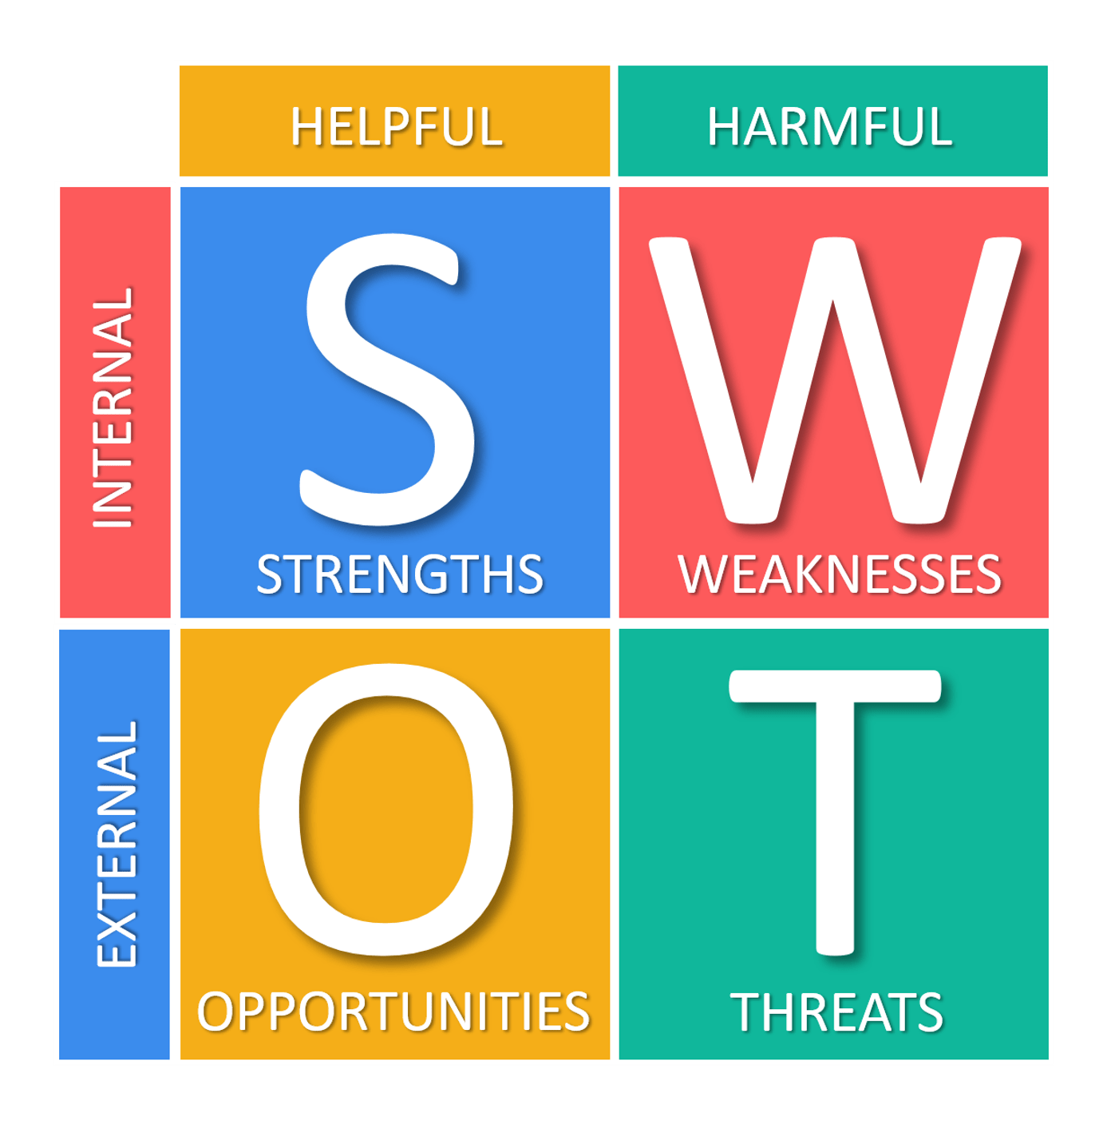
Figure: SWOT analysis of SEVEN
Source: (Belgium Economic Snapshot - OECD, 2020)
Effective research and development: To enter into the new market SEVEN has enhanced its research department that helps to enter into the market of Belgium and Nederland. The company is focusing on developing new products for the UK market that will ensure maximum market share in the UK market (Cox, 2020). So, developing the best quality market and focusing on the next target demand of the customer is a good strength of SEVEN Company.
Substantial profit margin: The SEVEN has good scope to make a substantial profit margin in the UK market. Even though the management has made a loss in 2020 in the UK market, the company expects that it will improve its profit margin in the next years (Companies Go International, 2020). The management has decided to apply product leadership as well as cost leadership strategy so that it can ensure customer loyalty so fast. The management of SEVEN expects next year's net profit will be € 5, 900, 000.00. So, the company can be achieved a substantial profit margin.

Weaknesses
Weaknesses of a business organisation create obstacles to ensure the highest performance. The SEVEN has some limitations in the UK market as well as the foreign market.
Ineffective team management: The SEVEN has spent € 76, 861,762.87 for administrative cost but the performance was not equal the expectation. Comparing to the company planning some department has a negative performance which causes losses of the company. The management also failed to manage every team to ensure maximum outcomes. So, the management thinks to reorganise some team to get the best outcomes.
Dependency on supplier: Highly dependent on suppliers makes a business weak and it has to struggle much to ensure targets of the company (Okpara,2020). In the UK market, the SEVEN faced this problem because it has very few suppliers that’s why it has limited opportunity to bargain with them. In the UK market at several weeks, the company has a very low inventory that influences sales operations as well as the overall performance of the company (Deventer, 2019). So, to ensure the smooth operation of the company management needs to increase the number of suppliers as much as possible.
Opportunities
The SEVEN has some opportunities in the UK as well as Belgium and Nederland’s market by which the company can increase its market share and profitability performance.
Increasing market demand: The market demand for smartphones is increasing every day. According to the report, the current smartphone user is 2.9 billion which was 2.5 billion before few years and market analysts expect that within 2025 it will be around 4.00 billion (Belgium Economic Snapshot - OECD, 2020). Based on the company analysis in the Belgium market, the demand for smartphones is around 20, 00,000 per year. So, the SEVEN has a big opportunity to capture market share by providing quality products.
Diversification opportunity: The research and development department of SEVEN is so strong and efficient that it designs the best quality products for Belgium and Nederland’s market. The company can apply a diversification strategy for both Belgium and Nederland’s market. The diversification strategy allows to open a new market with new products (Holmes, 2019). The success of the diversification strategy mostly depends on the marketing operation of the company where it has a strong and experienced marketing team to ensure the success of the company.
Threats
Threats are the obstacles that reduce competitive advantages as well as the success opportunity of the company. The SEVEN is facing several threats in both domestic and foreign countries that are addressed below:
Increasing rivalry: In every market in the world smartphone companies are facing immense competition. Due to technological development companies are producing new quality phones very fast. And, they add new features in their existing phones (Okpara,2020). On the other hand, the new entry in the industry with new technology is another big threat of the SEVEN Company. So, the management should focus on developing new quality at a reasonable price too reduce this rival in the market.
Legal threats: The SEVEN is facing extreme threats due to legal and regulatory issues. The company must maintain different rules and regulation like employment law, minimum wage law, equality law 2010, labour law, environment act 1995, etc. (Hassanien and Dale, 2020). The Brexit is another big issue for the SEVEN to expand business in the European countries. The operational cost, as well as labour cost, has increased due to the Brexit issue.

Generic strategies
Competitive advantages in the market have increases the strengths of a business organisation. The best use of advantages reduces threats in the market. There are four generic strategies and the SEVEN can apply one or more strategies based on the situation.
Product strategy: The SEVEN can apply product strategy by developing the best quality products. The product strategy will help the company to become a quality branded company in the industry (Okpara, 2020). The company must focus on quality to isolate the company from the competitors so that customers can identify as the best quality provider company.
Cost leadership: The SEVEN can also apply a cost leadership strategy that allows providing products at the lowest price but ensuring the quality. The management has decided to apply a cost leadership strategy in the market to get every level of customers (Andersen, 2020). By applying this strategy, the company wants to build a strong customer relationship that will provide long-term benefits to the company.
Customer intimacy: Building customer intimacy should be the priority consideration of the SEVEN to get the highest customer response from the market. A good customer intimacy works as promotional activities in terms of customer promotion (Lynch, 2018). The management has decided to build customer intimacy in the UK market.
Stuck in the middle: The management of SEVEN can apply all three strategies in a market based on the situation analysis (Belgium Economic Snapshot - OECD, 2020). The application of more than one strategy depends on the market situation. The management has decided that in the Belgium market the company will apply both product and cost leadership strategy to ensure maximum satisfaction of the customers as well as ensuring the highest profitability performance.

Growth strategy
The management of SEVEN needs to apply a growth strategy to identify future growth in the projected market. The SEVEN can apply the Ansoff Matrix growth strategy to formulate a sound growth strategy of the company.
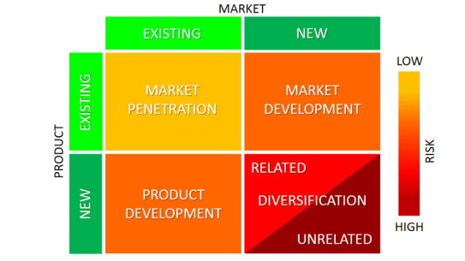
Figure: Ansoff Matrix
Source: (Organizational Structures, 2020)
Product development: The management of the company is focusing on developing new products for the UK market that will ensure maximum market share in the UK market. Product development allows providing new products in the current market where customers get new experience (Yang, 2020). The management has decided to apply product leadership by developing a new product for both local and foreign markets.
Market development: Based on the performance in the existing market a business organisation decides to develop a new market or not. So, based on the performance in the UK market, the management of SEVEN has planned to enter into Belgium and Nederland’s market in the next year. Market development allows a company to enter into a new market with existing products (Hassanien and Dale, 2020). In the UK the company has a good position and customers welcomed its products that inspired the company to develop a new market.
Market penetration: The management of SEVEN needs to focus on market penetration where it allows to increase of market share in the existing market with existing products. To ensure market penetration SEVEN needs to increase marketing performance to get more customers (Hanna, 2020). In 2020 the company has made €-60.131.421, 63 loss in the UK market. So, by using the market penetration strategy the management must ensure the profitability performance.
Diversification: The SEVEN can apply diversification strategy in Belgium and Nederland’s market that allows the company to enter into a new market with new products. The company has planned to enter Belgium and Nederland’s market in the next year where the management can provide new products to attract the highest number of customers.

Discussing the choice of the Netherlands and Belgium over territories
To equip everyone in the world with a technological ecstasy, SEVEN has designed a sophisticated plan to manufacture a Smartphone at an unprecedented lower cost in the Netherland. It would be an ultimate opportunity to scale back on cost if the company can supply form this European zone to the nearby destinations including Belgium (Peng, 2020). China could have been a potential option to set up a manufacturing unit due to the even lower labour cost which is only 21% of the cost of labour in the UK but transportation expense will shoot up to 45% (Simmonds, 2019). Hence it will not be financially feasible to go ahead with China.

Discussing the consequences of choosing the Netherlands over other countries
The directors of SEVEN have revealed that the labour cost in the Netherlands is only 1/3rd of the cost in the UK. Transportation of the Netherlands is even economically feasible for goods transferring in and out (Organizational Structures, 2020). Henceforth, the company is considering commencing next production epicentre in the Netherlands to seduce the geographical forte of the country. This is how the cost leadership approach can be exposed to the marketplace (Pickett, 2020). Thus, the company will be in a financially comfortable position in yielding the benefit of both geographical locations as well as low labour cost. Besides, the Netherlands is flourishing economically and is the next potential hub for an affordable Smartphone selling zone. The directors of SEVEN are pondering over pursuing a cost leadership strategy, so it will be evidenced as a booming market for them with a market share of 24%.
Nevertheless, the looming bottleneck which might take aback the synergistic effort in the Netherland is that the warehouse can accommodate only 10,000 handsets, without any alternative resort of superfluous inventory.

Discussing the reason for investment in specific functions
Companies tend to invest in operational activities so that they can derive the highest value out of it for their customer and hence build a long-term customer relationship. Several departments in an organisation work together as a single unit through Enterprise Collaboration Systems (ECS) to generate superior value under the team spirit (Sadler, 2020). The successive points clarify how different operational activities worth investing-
Organisation: SEVEN requires a justified combination, coordination and collaboration for the activities through a specific hierarchy of managerial positions (Collier and Collier, 2020). It is certain that without adequate pushing through the chain of command, even mandatory tasks get postpended resulting in loss and penalties to the entity (Holmes, 2019). SEVEN needs to build such an international hierarchy which will be autonomous in deciding any issues to arise therein and become concentrated in choosing strategies. Management of SEVEN must consider the following
For Belgium
Cost heads | Average amount (€' millions)
Salary expense | 230
Advertising expense | 50
Lease instalment | 180
Maintenance cost | 45
Overheads | 210
Total | 715

Human Resource: Workforce is the base upon with SEVEN can ensure purveying consistent quality to its customers. Following justifies the reason for investing in human resource activities-
- Human Capital Management (HCM) support system installation cost is €15,000 and licensing cost is €15,000.
- External freelancers are highly expensive €85,000 per year if SEVEN opts not to employ full-time employees (FTEs)
- Annually SEVEN will recruit not less than 25 employees.
- HQ employees receive up to €36,575 per person as salary with bonuses as follows-
Performance bonus apportionment for 43 employees
Structure | Calculation | Bonus (€)
10% outperforming | 43*10%*36575*4.5% | 7,077
80% performing | 43*10%*36575*2.5% | 3,932
10% underperforming | Nil | 0

Product: The directors of SEVEN have determined cost of a single smartphone at €96.65 which is most affordable by the people in the Netherlands and Belgium. Following facts justify investment in product development:
- Installing simulation research machine which will enhance productivity by 50% with an investment of €12,500.
- If research activities are duly carried out the production cost will drop by 20% in 2021.
Distribution: SEVEN needs to be mindful of the distribution chain as due management of such activities can lower the cost of selling final goods to the customers (Collier and Collier, 2020). SEVEN would like to engage Worldwide Shipping Ltd. (WSL) for delivery of goods to and from the Netherlands and Belgium. It is the most reliable distributor of SEVEN as it ensures timely delivery in 4 weeks, less carbon emission and consistent service. Nevertheless, the agreement with this LSP states that WSL will claim 5% turnover bonus only if the sales of SEVEN exceeds 2 million thresholds.
Marketing: Without marketing campaigns on a regular interval, SEVEN cannot flourish well in Belgium and the Netherlands as acute competition prevails in those countries. Investment of at least 2.5 million will be required to finance marketing activities-
- Search Engine Optimization (SEO) is required to ameliorate the Google ranking at an extensive level at a cost of €25,000.
- Price Per Click (PPC) packages can ensure 20,000 clicks per annum to SEVEN’s website.
- Advertising agencies can be engaged to design and propagate marketing campaigns.
Financial: To finance the working capital requirements SEVEN might need to subscribe to loans as its receivables days is 30 plus. Following justifies financial requirements-
- If SEVEN tightens the credit policy its receivables will switch to competitors. So, it can allure receivables payment by offering a 5% discount if paid within 15 days to finance the working capital needs.
- The finance team will prepare a capital budgeting analysis to find out the potentiality of investment in any of the new projects.
- Debt financing cost is only 2% but he required rate of return (RRR) of SEVEN’s stakeholders in 7%. So, it is better to finance the business using debt.

Explaining why investment will impact positive or negative growth
If investment activities are carried on considering its feasibility, return and other environmental factors then it is likely to pave the way for business growth. Nevertheless, there looms uncertainty. SEVEN needs to invest in human resource activities to select and recruit competent employees. Besides, working capital decisions, investment decisions, budgetary variance analysis etc. provide a discrete decision-making ability by the finance team of SEVEN. As has been projected by the directors of SEVEN, sales can be reached to an unprecedented level by increasing 45% marketing expense in SEO and PPC schemes (Trading economics, 2020).

Analysing how choices and strategies created value
SWOT analysis, Porter’s 5 forces model, Ansoff model etc. have underpinned SEVEN to formulate strategies and undertake decisions in operations. SWOT analysis depicted the following-
SWOT Elements | Analysis | Value creation
Strength | Lean production system | Cost leadership
Weakness | Raw materials price increase | In-house production
Opportunities | Distribution channel | Lower cost
Threats | Tax rates may sore in the Netherlands and Belgium | Research activities to reduce cost

Ansoff matrix demonstrated that SEVEN can develop a potential market of its offering in the Netherlands and Belgium by dint of its cost leadership strategy. Moreover, the company is contemplating to expand its manufacturing operation in the Netherlands apart from its UK manufacturing unit to leverage 43% low labour cost.

Critical use of theoretical insights and analytical frameworks to assess strategic, competitive and performance implication
SEVEN has demonstrated certain competencies in developing an analytical framework and deeper insight regarding its global strategy formulation. The company has been pondering to initiate its operation in the Netherlands by considering its low labour cost, flexible and lean transportation system and a potential market share of 24%. Not least, the company will be able to consummately pursue its cost leadership strategy by commencing its manufacturing epicentre in the Netherlands. Nevertheless, the warehouse in the Netherlands can only accommodate 10,000 pcs of handsets. In such a case, production must be compatible with selling to minimise the piling up of inventory (Collier and Collier, 2020). Regarding Belgium, both SWOT analysis and Porter's 5 forces model revealed that the Tax implication can be a major issue. Corporate tax rates may spiral up to 37% from its existing 35%.

Conclusion
The affordable smartphone manufacturing entity, SEVEN has been predicted to be the leading light in history for purveying a superior quality smartphone at a reasonably lower price. The company looks forward to leveraging the lower labour cost in the Netherlands and hence commence its next production epicentre by considering the bottleneck that the warehouse capacity is only 10,000 pcs of smartphones. KPI regarding profitability indicates that it must shoot by 110% up to €5,900,000 from its current losing position. Ansoff matrix referred that SEVEN should develop the market in both the Netherlands and Belgium due to its cost leadership strategy. The prime threat as depicted by SWOT analysis states that corporate tax rates my sore up by 2% in Belgium thrusting lower profitability. No matter how insignificant threat screening may result in, SEVEN needs to consistently keep a vigilant eye on this factor.

References
Lynch, R., 2018. Strategic Management. Harlow, United Kingdom: Pearson Education Limited.
Hassanien, A. and Dale, C., 2020. Hospitality Business Development. 10th ed. New York: Springer.
Peng, M., 2020. International Business. 14th ed. New York: Cengage Learning.
Pickett, K., 2020. Enterprise Risk Management. 15th ed. Hoboken, N.J.: Wiley.
Rejda, G., McNamara, M. and Rabel, W., 2020. Principles Of Risk Management And Insurance. 15th ed. London: Springer.
Holmes, A., 2019. Risk Management. 15th ed. Oxford, U.K.: Capstone Pub.
Cox, L., 2020. Improving Risk Analysis. 14th ed. New York, NY: Springer New York.
Deventer, D., Imai, K. and Mesler, M. (2019). "Advanced financial management.
Dyer, J., 2018. Strategic Management. New York: Wiley.
Okpara, J., 2020. Globalization Of Business. 1st ed. London: Adonis and Abbey Publishers Ltd.
Simmonds, K., 2019. Strategy And Marketing Strategy & Marketing. 11th ed. Oxford: Allan.
Sadler, P., 2020. Strategic Management. 10th ed. New-Delhi: Kogan page India Pvt. Ltd.
Qu, W. and Yang, Z., 2020. The effect of uncertainty avoidance and social trust on supply chain collaboration. Journal of Business Research, 68(5), pp.911-918.
Hanna, 2020. Effective Staff Management Is The Backbone Of Your Business. Humanity.com. Available at: <https://www.humanity.com/blog/effective-labor-management-is-the-backbone-of-your-business.html>
Glaister, K., Husan, R. and Buckley, P., 2020. International joint ventures: an examination of the core dimensions. Journal of General Management, 30(4), pp.43-72.
Fang, T., 2020. A Critique of Hofstede’s Fifth National Culture Dimension. int j cross cult manages, 3(3), pp.347-368.
Collier, E. and Collier, E., 2020. Corporate Social Responsibility For Your Business. The Hub | High-Speed Training. Available at: <https://www.highspeedtraining.co.uk/hub/importance-of-corporate-social-responsibility/>
World Bank. 2020. June 2019 Indonesia Economic Quarterly: Oceans Of Opportunity. Available at: <https://www.worldbank.org/en/country/indonesia/publication/june-2019-indonesia-economic-quarterly>
Tradingeconomics.com. 2020. India GDP Annual Growth Rate | 1951-2019 Data | 2020-2022 Forecast | Calendar. Available at: <https://tradingeconomics.com/india/gdp-growth-annual>
Oecd.org. 2020. Belgium Economic Snapshot - OECD. Available at: <https://www.oecd.org/economy/belgium-economic-snapshot/>
Velocity Global. 2020. Top 6 Benefits Of Doing Business In The United Kingdom. Available at: <https://velocityglobal.com/blog/top-6-benefits-business-united-kingdom/>
Andersen, O., 2020. On the Internationalization Process of Firms: A Critical Analysis. J Int Bus Stud, 24(2), pp.209-231.
Bradley, F., 2019. International Marketing Strategy. 10th ed. Harlow: Financial Times Prentice Hall.

