Executive summary

Maliban Biscuits Corporation is planning to implement fleet management system to monitor and control the distribution vehicles network of the organization in order to reduce the non-value adding activities of distribution process. The fleet management system can be used as a vehicle tracking system to identify the correct locations in real time basis.
It includes engine on and off options to control the vehicle running capacity and remotely monitor the fuel efficiency of the vehicle in order to avoid the environment to involving fraud activities with respect to fuel. The report includes the critical discussion over quality management, risk management and communication management for the project.

Table of Contents

01. Introduction 3
02. Feasibility of the project 3
03. Statement of work for the project 4
3.1 Introduction 4
3.2 Scope of work 5
3.3 Period of performance 5
3.4 Work requirements 6
3.5 Milestones 6
3.6 Acceptance criteria 6
04. Work Breakdown Structure of the project 7
05. Project Gantt chart 9
06. Project cost distribution plan 10
07. Quality management plan for the project 11
08. Risk management plan for the project 12
09. Communication management plan for the project 13
10. References 15

Introduction

The report discusses the project management strategies and approaches to project management process of existing Sri Lanka organization. Maliban Biscuits Corporation is considered as the main business organization to discuss the project management initiatives and approaches. Maliban Biscuits Corporation is planning to implement fleet management system to monitor and control the distribution vehicles network of the organization in order to reduce the non-value adding activities of distribution process. In this report it is discussed the feasibility of the project to Maliban Biscuits Corporation in order to management distribution process. Further it includes work breakdown structure and statement of work to plan the project activities. Further the report includes budget distribution plan, risk management plan, quality management plan and communication plan for the project.

Feasibility of the project

The organization is planning to implement fleet management system to the organization in order to manage the product delivery process. Currently business organization has more than 200 vehicles to distribute the biscuits products around Sri Lanka. When compare to the production cost and distribution cost there is a significant portion amount of financial and non-financial resources need to be allocated in order to control and manage the distribution process. Internal audit report highlights that there are fraud indications have happened with respect to the fuel management and misappropriation of distribution vehicles by the drivers and their helpers. The primary objective of fleet management system is to monitor the locations and route of delivery vehicles to compared with predetermined distribution map of the organization (Altshuller & Clarke, 2005). In addition to that fleet management system can be used to ensure the security of the distribution vehicles as well. That means fleet management system can be used as a vehicle tracking system to identify the correct locations in real time basis. It includes engine on and off options to control the vehicle running capacity and remotely monitor the fuel efficiency of the vehicle in order to avoid the environment to involving fraud activities with respect to fuel. as a result of used in fleet management system within the organization it can be reduced cost absorption for distribution process and reduce the operational complexity by eliminating manual internal control practices to monitor the vehicle distribution process. The project takes at least twelve months periods to complete the project activities and make project ready to conduct pilot testing. In addition to that organization is expected to use internal ICT management human resource to plan and implement the fleet management system within the organization. As a result of having a proper fleet management system within the organization it will create the efficiency and effectiveness of business distribution process. That means business organization can take the right business decisions in order to manage the distribution process of the organization based on the real-time data which are extracted from fleet management system. In addition to that it can be used to monitor the performance of drivers and their supporters in order to take the human resource management decisions based on the actual performance of the employees. That means fleet management system adds financial and non-financial values to the business entity in order to achieve the functional goals and objective.

Statement of work for the project

3.1 Introduction

Statement of work document is used to communicate and document the project objectives and project milestones. Considering the scope of project of objectives project milestones have been determined and it is expected to change the project milestone during the project period based on the drawbacks and limitations to achieve the project objectives (Altshuller & Clarke, 2005). In addition to that statement of work includes acceptances criteria which should be considered in order to evaluate the project feasibility and project performance to identify whether existing project activities have been created positive implications to achieve the project objectives. In addition to that it discusses how project work requirements should be planned and how organization should integrate the existing resources with internal and external environmental implications to execute the project activities and achieve the project objectives within the period of time.

3.2 Scope of work

In planning the scope of work to implement the plate management system within the organization it is considered the indications and interpretations of internal audit reports which includes the business problems and issues which are related to failures in fleet management process. in addition to that it is considered a competitive business organizations fleet management Strategies and practices in order to monitor the distribution of vehicles to reduce the fuel consumption cost and tractor vehicles in real time basis (Project Management Institute, 2008). In addition to that it is considered impact from internal and external business environment factors which can be create limitations to achieve the project objectives due to unexpected environmental changes. Fleet management system is to monitor the locations and route of delivery vehicles to compared with predetermined distribution map of the organization. In addition to that fleet management system can be used to ensure the security of the distribution vehicles as well. That means fleet management system can be used as a vehicle tracking system to identify the correct locations in real time basis.

3.3 Period of performance

Performance period of the project activities takes 12 months period to complete the overall project activities. It allocates considerable period of time to plan the project statement of work with respect to determine the project objectives and implement the project milestones in order to evaluate project performance (Stout et al, 2014). In addition to that it is given more priority to plan the project activities based on the work breakdown structure and schedule the project activities using project management software. With respect to that quality management initiatives of the projects have been developed during the middle part of project cycle in order to monitor whether project activities are function in with respect to the proper quality assurance process. In addition to that financial resources and non-financial resources to the project of plan and allocate at the initial stage of the project based on the internal competencies of the business organization. During the last stage of project management process it is given more priority to control and monitor the project activities to ensure that project have been completed with respect to the planning project milestones.

3.4 Work requirements

At the project planning stage it is essential to review the impact of business environment factors to identify the required areas which need to be address in fleet management system. Based on that organization should plan their features and specifications which need to be included in fleet management system in order to manage the distribution process and reduce the risk and cost to execute the distribution activities. In order to execute the project activities it is essential to recruit new software developers to the business organization who have capabilities in terms of work in meet GPS tools. In addition to that project activities should be executed considering the existing financial and non-financial resources of the business organization and scope of the project should be planned based on the internal competencies and drawbacks to achieve the project activities. Otherwise business organization will not be able to achieve the objectives of the business organization through the project within predetermined time period. During the completion stage of the project it is essential to conduct the critical review of actual project outcomes with expected project outcomes. It will help to identify with project activities have been helped to achieve the project objectives and what are the actions which need to be taken in order to fill the gaps between expectations and actual outcomes of the project.

3.5 Milestones

Planning statement of work | January 31, 20xx
fleet management process planning | February 31, 20xx
Prioritizing fleet management activities | March 31, 20xx
Initiating fleet management process | April 31, 20xx
Understanding the business performance expectation | May 31, 20xx
Implementing fleet management strategies | June 31, 20xx
Executing fleet management strategies | September 31, 20xx
Planning the corrective actions | October 31, 20xx
Controlling the overall fleet management process | December 31, 20xx

3.6 Acceptance criteria

Project acceptances criteria should be plan based on the financial outcome and non-financial outcome of the project. That means business organization should have proper mechanism to even with the project objectives have been achieved based on the interpretations and implications of project acceptance criteria. The fleet management system is developed to monitor the locations and route of delivery vehicles to compared with predetermined distribution map of the organization. In addition to that fleet management system can be used to ensure the security of the distribution vehicles as well. That means fleet management system can be used as a vehicle tracking system to identify the correct locations in real time basis.Project acceptance criteria are as follows;
- Reduce the annual distribution cost of the organization by 20% as a result of proper monitoring and execution process to manage the fleet management process.
- Reduce 10% of annual human resource management cost to manage distribution activities of the business organization by automate in the distribution monitoring process using fleet management system.
- Reduce the 10% of fuel consumption for the distribution vehicles annual basis.
- To monitor the real-time operations of distribution vehicles based on the GPS map option.

Work Breakdown Structure of the project

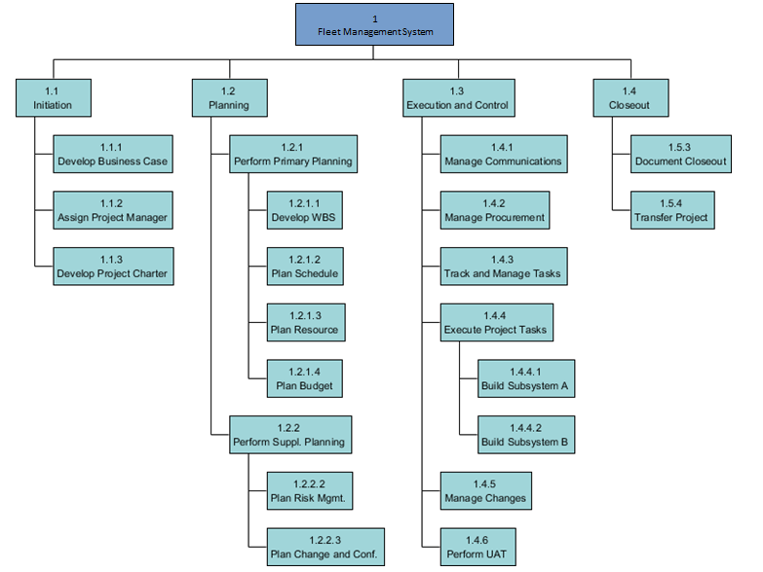
Project breakdown structure includes for stages such as initiation, planning, execution and closeout. During the pledge project initiation stage it is considered how to develop the project case based on the distribution process problems and issues of the organization. In addition to that it is define the roles and responsibilities of the project managers in order to achieve the project goals and objectives. Further it is essential to develop the project charter which includes all the project activities based on the project timeline which have been integrated with project objectives and goals. During the project planning stage it is considered how to develop the project activities which project objectives in order to compile with project milestones. During the project planning stage it is executed cost distribution analysis for the project activities based on the available financial and non-financial resources and plan the project schedule based on the limited time period to achieve the project objectives. In addition to that it is develop the project risk management strategies to mitigate the risk which are created from internal and external environmental factors. During the project execution stage it is essential to monitor the project activities in order to ensure that our project activities are functioning with respect to the goals and objectives and predetermined time period. In addition to that it is essential to perform various analyses for each project activities to ensure that activity related project milestones have been met throughout the project period. That means project management initiatives should be used to track the project activities during this stage. Project documentation can be executed using hard documentation and soft documentation. In modern business world most of the business organizations are used in online platform to store the documentation which has been executed use in the hard documentation strategies.

Project Gantt chart

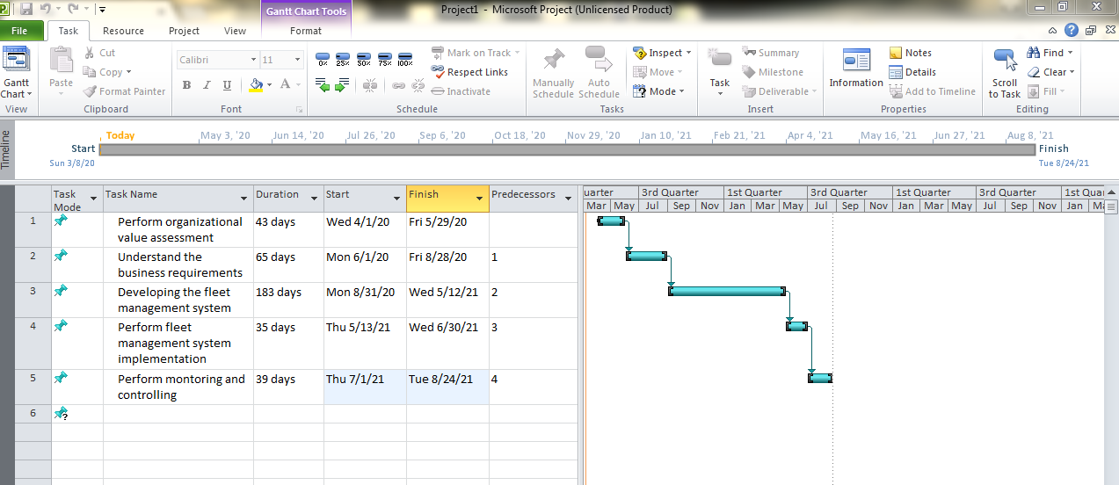

Project time schedule plan includes the organization of value assessment should be completed within 43 days. in addition to that it is required to allocate 65 days to understand the business requirements of the organization in order to develop the fleet management system based on the proper understand in about distribution process related issues and problems. More than 50% of time allocation of the project schedule has been assigned to development of fleet management system. 183 days have been allocated to develop the plate management system of the organization and 35 days have been assigned to perform the fleet management system implementation related activities. In addition to that is required to perform various analyses for the project activities based on the expected outcome and actual outcome of the project. For that purpose 39 days is allocated to perform the monitoring and controlling activities of the project.

Project cost distribution plan

Description | Required Human Resource Hours | Per Hour Rate for Human Resource (LKR) | Cost Per Human Resource (LKR) | Required Number of Human Resource | Total Projected Cost (LKR)
Organizational values assessment
Recognizing the values of the organization | 25 | 3,000 | 75,000 | 4 | 300,000
Understand the current distribution process | 28 | 3,000 | 84,000 | 6 | 504,000
Identification of consideration factors of distribution process | 32 | 3,000 | 96,000 | 4 | 384,000
Review business environment | 33 | 3,000 | 99,000 | 3 | 297,000
Gather stakeholders ideas and views | 25 | 3,000 | 75,000 | 5 | 375,000
Implement the change management strategies | 24 | 3,000 | 72,000 | 8 | 576,000
Hire software developers | 27 | 3,000 | 81,000 | 6 | 486,000
Develop the project communication plan | 28 | 3,000 | 84,000 | 4 | 336,000
Understanding the business requirements
Determine the values of fleet management system | 27 | 3,000 | 81,000 | 6 | 486,000
Define the project goals and objectives | 33 | 3,000 | 99,000 | 5 | 495,000
Integrate with existing business processes | 32 | 3,000 | 96,000 | 3 | 288,000
Implement fleet management system implementation strategies | 26 | 3,000 | 78,000 | 4 | 312,000
Link with functional and corporate objectives | 27 | 3,000 | 81,000 | 7 | 567,000
Perform fleet management system pilot tests | 25 | 3,000 | 75,000 | 6 | 450,000
Understanding the practical implementation problems | 27 | 3,000 | 81,000 | 5 | 405,000
Developing the fleet management system
Gathering the system requirements from the management | 34 | 3,000 | 102,000 | 3 | 306,000
Develop the UI and UX | 34 | 3,000 | 102,000 | 4 | 408,000
Coding the fleet management system | 36 | 3,000 | 108,000 | 8 | 864,000
Perform the quality assurance and quality review actions | 39 | 3,000 | 117,000 | 7 | 819,000
Rectify the quality assurance issues and problems | 42 | 3,000 | 126,000 | 5 | 630,000
Perform fleet management system implementation
Install the GPS tools to vehicles | 29 | 3,000 | 28,000 | 5 | 140,000
Perform review on fleet management system accuracy | 31 | 3,000 | 32,000 | 3 | 96,000
Implement to all the vehicles | 38 | 3,000 | 46,000 | 7 | 322,000
Total cost for the project |  |  |  |  | 9,846,000

Quality management plan for the project

Quality management strategies of the project should be planned at the initial stage of the project in order to identify the project objectives and use quality management strategies to achieve the project objectives (Amaral et al, 2011). That means when organization plan the project activities it is essential to determine the project objectives with respect to the quality management expectations. In this project it is expecting to implement total quality management strategies with the project activities in order to ensure that project scope meet the expectations of distribution process of the organization and it ensure the high level of quality assurance to the business fleet management services.
In order to plan the quality management strategies of the project it is expecting to consider the ideas and views of the human resource of the business organization. Existing employees of the business organization have comprehensive understanding about existing problems and issues of fleet management system within the organization and what are the approaches and techniques which need to be applied in order to achieve the fleet management system related goals and objectives and how to overcome the existing issues of distribution process (Amaral et al, 2011). In order to implement proper project related quality management framework it is essential to integrate the organizational quality management strategies with the project management approaches. That means business organization should have proper mechanism to compare the project related quality management approaches and expectations with firm specific quality management initiatives. As a result of that business organization can use project management tools and techniques in order to achieve the business organizations quality management expectations as well (Caskey & Hughes, 2012). In most circumstances project quality management approaches are changed with respect to the changes in functional management strategies of the business entity.
In addition to that it is essential to identify the quality management gaps of the business organization with reference to problems of fleet management system which have been highlighted in internal audit reports of the business organization. That means it is considered the recommendations of internal audit reports which have been highlighted in order to overcome the problems of a distribution management process of the organization in order to enhance the efficiency and effectiveness of distribution process and covered wide area in Sri Lanka to ensure the proper market expansion process (Caskey & Hughes, 2012). Business environment factors are changing rapidly and business strategist need to be changed with respect to the changes in business environmental forces. In this project it is expected to integrate the project management activities with change management strategies in order to identify the changes in internal and external business environment with respect to implementation of fleet management system and update the project activities with respect to the changes of business environment forces (Caskey & Hughes, 2012). Quality management strategies of the project should be reviewed periodically in order to ensure that quality management strategies are functioning properly and determine the optimum quality management approaches which need to be integrated with project activities to achieve the project objectives.

Risk management plan for the project

Risk management process includes strategic approaches and techniques to identify the risk in business environment and rate the risk in order to develop the risk mitigation strategies. The primary objective of risk management process is to predict the future risk possibilities to the business organization and implement the business level strategies and corporate level strategies to mitigate the negative implications of future risks (Aydinliyim & Vairaktarakis, 2013). In implementing the risk management strategies within the business entity, it is considered both implications from internal and external business environment factors to ensure the effective and efficient implementation of risk management framework. The main risk of this project is lack of adequate human resource to execute the project activities. it is recommended to conduct project risk assessment at least monthly basis during the project period in order to evaluate whether determine and establish risk management strategies for the project are suitable to identify the internal and external risk associated with the project (Jordan et al, 2013). For that purpose it is essential to have proper risk management knowledge and competencies to the project manager and business organization should evaluate the risk management capabilities of the project management at the time of project manager hiring process. In addition to that it is essential to change the risk management and assessment approaches with respect to the changes in business environment factors to compatible with risk management initiatives with environmental changes.
Currently business organization does not have adequate human resource who have capabilities on develop in GPS related fleet management system to the business organization and it is essential to recruit new software developers to the business organization. it is required at least 5 software developers who have knowledge and skills on GPS related fleet management system and develop the PHP software to run the fleet management system online basis. Employees of the business organization have to change to new fleet management system from existing manual controls and business practice to control and monitor the vehicle distribution process (Aydinliyim & Vairaktarakis, 2013). Risk of creating employee reluctant to change to new fleet management system due to non-familiar with existing system of the business organization and business organization should have proper mechanism to implement change management system and strategies to overcome the negative implications from employee resistance to change. In addition to that it is essential to communicate that vehicle distribution process is monitoring by the head office managerial employees to the drivers and supporters. As a result of that there is a risk of decrease in the job motivation of drivers and supporters due to feeling of someone are monitoring their performance (Jordan et al, 2013). As a result of that there is risk of increasing the employee turnover from drivers and supporters of the business organization.
In addition to that, most of the business organization in modern business world exposing to cyber security risk. That means fleet management system related data are stored in clouds servers. As a result of that there is a risk of unauthorized access to the data of the fleet management system and those data can be manipulated in order to mislead the business decisions making process. In addition to that it is recommended not to take the direct decisions based on the existing data of the fleet management system due to their risk of system errors which can mislead the business decisions making process on fleet management process. For that purpose it is essential to evaluate the trend analysis of fleet management system data in order to identify the significant and unusual deviations.

Communication management plan for the project

Business communication process means there should be a two way communication approach between two or more parties in order to share the knowledge and competencies to achieve the business goals and objectives. Communication strategies with internal parties and external parties of project management process are important to achieve the project goals and objectives based on the effective and efficient communication practices (Brown et al, 2011). The primary objective of project management related communication strategies is to identify the real requirements and correct approaches which need to be applied in planning and executing the project management strategies and activities. In order to ensure the efficiency and effectiveness of project communication process it is essential to evaluate the barriers which can be created from organization structure. That means project roles and responsibility should be allocated and manage based on the flat organization is structural approaches. It ensures the efficiency and effectiveness of internal communication process between each hierarchy of the organization structure (Flyvbjerg & Budzier, 2011). In addition to that it is recommended to use modern technological advancement to ensure the efficiency and successful implementation of project communication techniques and tools.
Management of the business organization should communicate with software developers in order to communicate the correct requirements and features which need to be address in fleet management system. That means management people of the business organization should communicate the software developers in order to develop correct features and specifications of the fleet management system to address the existing problems of distribution process (Brown et al, 2011). In addition to that internal communication process within the business organization is important to ensure the successful implementation of project management activities. For that purpose management of the business organization should gather the ideas and views of the employees regarding the existing problems of distribution management process and how those problems can be addressed using fleet management system features and specifications (Flyvbjerg & Budzier, 2011).
In addition to that is recommended to communicate with internal auditors and external auditors of the business organization to identify the practical issues of vehicle management process of the distribution network of the business entity and what are the observations and strategic approaches to mitigate the risk associated with those problems and issues. once fleet management system is completed is it is required to communicate the drivers and supporters to indicate that their performance and their activities are monitoring in real time basis so it will help to avoid the unethical practices from drivers and supporters perspectives. in addition to that management should communicate with business intelligence team with the organization in order to provide the clear guidance and directions to analyses the business intelligence data which are extracted from fleet management system in order to provide the correct information at right time to take the strategic and functional decisions based on the data in fleet management system. In addition to that management of the business organization should communicate with main stakeholders of the business organization in order to get the approval to implement the fleet management system within the organization and take the responsibilities of any technical and additional business risk due to implementation of fleet management system.

References

Altshuller, G. and D. W. Clarke. 2005. 40 Principles: TRIZ Keys to Innovation. Extended Edition. Technical Innovation Center, Inc.
Amaral, J. E. G. Anderson Jr. and G. G. Parker. 2011. Putting it together: How to succeed in distributed product development. MIT Sloan Management Review (Winter): 51-58.
Aydinliyim, T. and G. L. Vairaktarakis. 2013. A cooperative savings game approach to a time sensitive capacity allocation and scheduling problem. Decision Sciences 44(2): 357-376.
Brown, K. A., R. Ettenson and N. L. Hyer. 2011. Why every project needs a brand (and how to create one). MIT Sloan Management Review (Summer): 61-68.
Caskey, J. and J. S. Hughes. 2012. Assessing the impact of alternative fair value measures on the efficiency of project selection and continuation. The Accounting Review (March): 483-512.
Flyvbjerg, B. and A. Budzier. 2011. Why your IT project may be riskier than you think. Harvard Business Review (September): 23-25.
Jordan, S., L. Jorgensen and H. Mitterhofer. 2013. Performing risk and the project: Risk maps as mediating instruments. Management Accounting Research (June): 156-174.
Project Management Institute. 2008. A Guide to the Project Management Body of Knowledge. Project Management Institute.
Stout, D. E., R. N. West and M. J. Liberatore. 2004. Project management: A core competency in managerial accounting education. Management Accounting Quarterly (Summer): 53-61.

