Abstract

Current business world is highly competitive, and all the business organizations aim to ensure the high level of operational efficiency to meet the competition. In this research, author mainly discusses the implementation of lean management system in Sri Lankan apparel industry to meet the production deadlines and production requirements of the apparel industry. In this organization there was no proper mechanism to obtain the maximum commitment and contribution of the employees to implement efficient and effective lean Management process to enhance capabilities and competencies of the organization to develop the production goals and objectives. As a result of that understanding about the importance and significance of the lean management practices of employees is at minimum level compare to the other business organizations in the industry. Lean management Strategies and lean management practices of the organization should be updated with respect to the changes in internal environment factors and external environmental factors. Internal environmental preview involving identifying the strategic capabilities of the organization in order to implement most effective and efficient lean Management process within the organization. Over the period of time, management has not taken a single appropriate action to identify non-value-added activities and take an appropriate statistical approach. Organization must invest financial and non-financial resources in order to ensure the effectiveness and efficiency of lean management practices. It is recommended to review the warehouse Management process of the organization in order to integrate the warehouse Management process and production management process of the organization. To update the warehouse management Strategies and practices of the organization it is recommended to implement just in time inventory management system to reduce the time consumption on Inventory Management and inventory maintenance of the organization.

Table of Contents

List of tables 7
List of illustrations 8
Chapter 1 - Introduction 9
1.1 Introduction 9
1.2 Significance of research study 10
1.3 Research objectives 10
1.4 Research questions 11
1.5 Research problem 11
1.6 Research ethics 12
1.7 Research gaps 12
1.8 structure of the dissertation 13
1.9 Chapter summarization 13
Chapter 2 - Literature review 13
2.1 Lean management strategies and practices 14
2.2 Lean management-based quality assurance 16
2.3 Eliminating non-value adding activities 17
2.4 Advantages of lean management practices 19
2.5 Challenges of implementing the lean management strategies 20
2.6 Factors need to be considered in implementing the lean management process 21
3.Research methodology 23
3.1 Introduction 23
3.2 Conceptual framework 23
3.3 Research hypothesis 24
3.4 Working Definitions 26
3.6 Research Design 27
3.6.1. Time Horizon 27
3.6.2 Instrumentation 27
3.6.3 Target Population 28
3.6.4 Sample frame 28
3.6.5 Sample size 28
3.6.6 Sampling techniques 28
3.6.4 Data collection 29
3.6.5 Data analyzing techniques 29
3.6.6. Structure of the Questionnaire 30
3.6 Primary research data 30
3.6 Secondary research data 30
3.7 Research ethical considerations 30
3.8 Chapter summarization 31
4. Research data analysis 31
4.1 Introduction 31
4.2 Response Overview 32
4.3 Sample Profile 33
4.4 Research reliability testing 34
4.5 General research data analysis 35
4.6 Independent Variable analysis 37
Research hypothesis I – Warehouse Management Practices 37
Research hypothesis II – Supply chain management process 40
Research hypothesis III – Employee awareness 47
Research hypothesis IV – Management commitment 48
Research hypothesis V – Environmental review 49
4.4 Pearson’s correlation of coefficient analysis 52
4.5 Chi-Square method 53
5.Research conclusion and Recommendations 56
5.1 Introduction 56
5.2 Key Findings 56
5.3 Conclusion 56
5.4 Recommendations 59
5.5Areas for Further research 62
5.5 Limitations 62
References 62
Appendix 67
Survey Questionnaire 67

List of tables

Table 01 | Research Question 04
Table 02 | Research Question 02
Table 03 | Research Question 03
Table 04 | Research Question 04
Table 05 | Research Question 05
Table 06 | Research Question 06
Table 07 | Research Question 07
Table 08 | Research Question 08
Table 09 | Research Question 09
Table 10 | Research Question 10
Table 11 | Research Question 11
Table 12 | Research Question 12
Table 13 | Pearson's correlation of coefficient
Table 14 | Case processing summary
Table 15 | Reliability statistics
Table 16 | Cronbach’s alpha

List of illustrations

Figure 1 | Research Response Rate
Figure 2 | Marital Status of the sample population
Figure 3 | Working Experience of the Sample Population
Figure 4 | Research Question 01
Figure 5 | Research Question 02
Figure 6 | Research Question 03
Figure 7 | Research Question 04
Figure 8 | Research Question 05
Figure 9 | Research Question 06
Figure 10 | Research Question 07
Figure 11 | Research Question 08
Figure 12 | Research Question 09
Figure 13 | Research Question 10
Figure 14 | Research Question 11
Figure 15 | Research Question 12

Chapter 1 - Introduction

1.1 Introduction

Lean manufacturing system is used in most of the manufacturing organizations. The main objective of implementing lean manufacturing is to enhance the operational efficiency and effectiveness of the production process and other operational functions while reducing waste & cost in the organization. Current business world is highly competitive, and all the business organizations aim to ensure a high level of operational efficiency to meet the competition. In this research, author mainly discusses the implementation of lean management system in Sri Lankan apparel industry in order to meet the production deadlines and production requirements of the apparel industry. Further this research discusses how organization should develop the lean management strategies to integrate other operational functions with lean management system. In this research author discusses the theoretical interpretations of lean manufacturing system and how lean manufacturing system is practicing and applying in real work scenarios. The research contains five chapters such as research introduction, research literature review, research methodologies, research data analysis and research conclusion and recommendations.
Introducing lean manufacturing system increases the long-term operation performance and the organization’s value. It is a result of increasing the customer base as a result of touching new market segments through the products manufacturing process in the organization. The main challenge is employee resistance to change. Most of the employees are reluctant to change from traditional method to new method for the manufacturing processes. In addition to that management commitment is at lower position in implementing and executing the lean management related strategies and activities.

1.2 Significance of research study

Lean management process is linked with the production process of manufacturing organization. It ensures the proper coordination and integration among each operational function of manufacturing organization. Most of the manufacturing business organizations aims to increase the productivity of the production process using lean management related strategies and practices. Lean Manufacturing is a systematic approach for identifying and eliminating wastes (non-value adding activities) through continuous improvement by conveying the product at the pull of the customer in pursuit of production.
It will help to ensure the operational efficiency and effectiveness of the business operations in order to eliminate the non-value adding activities of operation management process. That means lean management practices monitor the production requirements frequently to decide the warehousing requirements and plan the procurement processes of the organization.

1.3 Research objectives

Research objectives should be determined at the research planning stage. That means overall research strategies and research approaches should be planned and executed based on the interpretations and implications of research objectives. In this research author has considered significance and importance of lean management system to ensure the operational process integration. Further it focuses on how organization should implement and execute the operational management strategies and practices to integrate the functional activities of the organization with lean management practices.

- To understand the factors which need to be considered in planning lean management strategies.
- To identify the overall supply chain management process of the organization.
- To identify the value stream of the process.
- To understand the lean management practices which can be used to improve production efficiency.
- To identify the non-value adding activities which need to be managed.

1.4 Research questions

In developing research questions, author considers what are the factors that should be evaluated and considered in planning the lean management related strategies and practices, how lean management process should be integrated with supply chain management strategies to ensure the efficiency and effectiveness of overall supply chain management process. Further it focuses on value stream of lean management practices and strategies. In addition to that research questions discuss how lean management process should be developed to improve the efficiency and effectiveness of overall production process of the organization.

- What are the factors which need to be considered in planning lean management strategies?
- What is the overall supply chain management process of the organization?
- What is the value stream of the process?
- What are the lean management practices which can be used to improve production efficiency?
- What are the non-value adding activities which need to be managed?

1.5 Research problem

Determining the research problem is important to determine the research strategies and research approaches. In determining the research problem, author considers the relationship between production process and lean management practices. The research problem statement considers how manufacturing organizations can increase the production process efficiency and effectiveness using lean management practices and strategies. In addition to that it considers the factors such as organizational culture, working conditions, operational practices etc. Considering those implications research problem is defined as “does lean management practices increase the production process efficiency?”.

1.6 Research ethics

Author uses the research data for the research purposes and prior permission of the research sample population is taken in transferring the research data to the third party. In addition to that author does not include the research questions which gather personal information of the research questionnaire participants.

1.7 Research gaps

Manufacturing industrial organizations can enhance the productivity of the operation process by implementing lean management system. That means lean management process creates better operational environment to manufacture a larger number of products using limited number of resources. As a result, resource consumption for the production will be decreased and it will cause to reduce the manufacturing cost as well. Lower manufacturing cost will create benefits over offering lower prices to the final products and it can be used as competitive advantage in the apparel industry to retain the existing customers and attract the new customers towards products of the organization. Production process of manufacturing organization consists of non-value adding activities. Non-value adding activities increase the production cost of the organization and lead to reduce the operational profitability as well. Production process continuation depends on the efficiency of the supply chain management process. Supply chain management process should be capable of issuing the material and resources to meet the production deadlines and maintain the production process continuation. Most of the researchers find the operational process implications on lean management practices such as production process, procurement process. In this research it is used both operational implications and non-operational implications such as human resource management, environmental review etc. to ensure the efficiency and effectiveness of lean management process. Lean management practices are used in manufacturing organizations. In most business organization consider only quantitative factors in evaluating the relationship between production process efficiency and effectiveness through lean management practices and strategies of the organization. In this research it is discussed both quantitative factors and qualitative factors in evaluating the relationship between product process efficiency and effectiveness through lean management practices and strategies of the organization.

1.8 structure of the dissertation

The dissertation contains five chapters such as research introduction chapter, literature review chapter, research methodology chapter, and research data analyzing chapter and research conclusion and recommendation. Further it includes references and annexure on research questionnaire.

1.9 Chapter summarization

In this chapter, author discusses the brief overview of research strategies and direction of the research. Author discusses the research objectives and research questions in this chapter. In developing research objectives and research questions, author considers factors that should be evaluated and considered in planning the lean management related strategies and practices, how lean management process should be integrated with supply chain management strategies to ensure the efficiency and effectiveness of overall supply chain management process. Further it focuses on value stream of lean management practices and strategies.

Chapter 2 - Literature review

2.1 Lean management strategies and practices

Lean management process is linked with the production process of manufacturing organization. It ensures the proper coordination and integration among each operational function of manufacturing organization. Most of the manufacturing business organizations aims to increase the productivity of the production process using lean management related strategies and practices (Buchanan et al, 1999). Lean Manufacturing is a systematic approach for identifying and eliminating wastes (non-value adding activities) through continuous improvement by conveying the product at the pull of the customer in pursuit of production (Shah & Ward, 2003). Lean management process mainly integrates with the production process of the organization. Systematic approaches to improve the production process and enhance the productivity are the main expectation of implementing lean management system in manufacturing organizations (Shah & Ward, 2003).
Manufacturing industrial organizations can enhance the productivity of the operation process by implementing lean management system. That means lean management process creates better operational environment to manufacture a larger number of products using limited number of resource. As a result, resource consumption for the production will be decreased and it will cause to reduce the manufacturing cost as well (Gowen, 2002). Lower manufacturing cost will create benefits over offering lower prices to the final products and it can be used as competitive advantage in the apparel industry to retain the existing customers and attract the new customers towards products of the organization. Production process of manufacturing organization consists of non-value adding activities. Non-value adding activities increase the production cost of the organization and lead to reduce the operational profitability as well. Lean management strategies will help to eliminate the non-value adding activities from the production process to enhance the productivity of the operation process. Lean manufacturing strategies involve with integrating and coordinating the operational functions of the organization (Adner, 2004). As a result of proper integration and coordination among each operational function of the organization, organization can enhance the operational efficiency in the normal course of business activities.
Most of the manufacturing organizations are struggling to meet the production deadlines with minimum resource availability. In order to meet the production deadlines, it is essential to have proper coordination between operational processes. Without proper coordination among operational processes, organization will face production delays (Adner, 2004). However, implementing lean management system in the organization will help to meet the production deadlines without production delays. Supply chain management strategies of the organization are important to ensure the production process efficiency. Supply chain management process should be capable of the issuing the required materials and resources to the production process to ensure the production process continuation. Lean management system ensures the mutual understanding and coordination between supply chain management strategies and production management strategies of the organization (Adner, 2004). Lean management strategies involve with screening the overall operation process to understand and evaluate the current and potential risks associate with operation process. It identifies the indications for potential inventory shortages, production delays, human resource shortages etc.
Lean Management process ensures the high level of business satisfaction through proper integration and implementation of functional management strategies of the organization. Lean management practices and strategies used to ensure a proper integration between operation and functions of the organization in order to achieve the business level objectives and corporate objectives of the organization. As a result of that implementation of lean Management process involved in creating various kind of benefits to the organization dynamic business environment. It is not used to ensure the continuation of successfulness of lean manager practices to achieve the production and non-production operational activities related goals and objectives. At the initial stage of implementation of lean management practices, it is important to understand how lean management practices can be used to integrate the operational functional strategies of the organization. In integrating the functional activities of the organization used in lean management operation and implications it is essential to evaluate the importance of each functional management activities and how those activities affect to functional management processes of the organization. However lean management practices cannot be applied to each and every business organization. Mainly lean management practices are suitable for the business organizations which have higher inventory levels and complex production management process. That means most of the manufacturing industry of business organizations can use Lean Management practices in order to generate competitive advantage positions in manufacturing industry in order to achieve the business level goals and objectives.
The primary objective of implementing lean management practices is to ensure proper and organize integration between functional management strategies of the organization to achieve business level goals and objectives. In addition to that business organizations aims to eliminate non-value adding activities in normal course of business process used in strategic approach of lean management practices and processes. However, there should be a relationship between goals and objectives of lean Management process and goals and objectives of the organization in terms of business level and corporate level. Success of the lean Management process is depending on support and commitment of the human resource of the organization. It can be categorized as non-managerial employees support and managerial employee support. Organization should have clear internal communication process to make the awareness of Human Resource regarding importance of line managers’ practices in order to get the maximum contribution and commitment to implement the effective and efficient lean management practices and strategies within the organization. Internal environmental resource capabilities and competencies of the organization need to be evaluated and assessed in development and planning the lean Management related strategic approaches. That means there should be a close relationship between inter environmental strengths and weaknesses in terms of developing and implementing the lean management activities to achieve business level goals and objectives and corporate level goals and objectives of the organization.

2.2 Lean management-based quality assurance

To ensure the quality assurance of final product of the production process, organization should evaluate the material qualities which are acquired from supply chain management strategies. Lean management process ensures the integration and coordination between quality management strategies and supply chain management strategies. It ensures lean management-based quality assurance in the organization. Waste management process is important to eliminate non-value adding activities of the organization (Buchanan et al, 1999). Lean management strategies aim to eliminate non-value adding activities of the organization. Waste management process involves with reducing non-value adding operational activities in the normal course of business activities. Lean management process ensures the integration between inventory management system and production management system. It helps to manage the minimum and optimum inventory levels in the warehouses and reduce the unnecessary operational costs for material holding and material handling (Adner, 2004). In addition to that organization can ensure the continuation of production delays without material supplying delays.
Due to the rapid change in business environment, supply chain management strategies also have been changed to be compatible to the changes on business environment. In addition to the dynamic and complex business life cycle creates barriers and challenges in implementing and executing supply chain management strategies. Lean management strategies play important role in ensuring the effectiveness and efficiency of supply chain management strategies. Supply chain management strategies involve in ensuring the material and other resource quality assurance to ensure the products quality assurance (Shah & Ward, 2003). Supply chain management strategies help to eliminate non-value adding activities in the operation process. Supply chain management processes screen the operational process of the organization to identify non-value adding activities and assess the adverse implications of those non-value adding activities.

2.3 Eliminating non-value adding activities

Production process continuation depends on the efficiency of the supply chain management process. Supply chain management process should be capable of issuing material and resources to meet production deadlines and maintain the production process continuation. According to Caro and Gallien, (2010) supply chain management process ensures eliminating non-value adding activities from the operation process of the organization. As a result, organization will be able to reduce the operation cost and impact on the profitability of the organization in positive manner. Management of the organization is responsible to make sure all the supply chain components have been integrated, does all the functions of supply chain process enhance the quality of operation process.
Efficiency of the inventory management system is essential to ensure the continuation in the production process. Having a proper integration between lean management and inventory management process, organization can reduce the material holding cost and material handling cost (Gebauer et al, 2009). Lean management-based inventory management system keeps minimum and optimum inventory level to reduce the material holding cost and material handling cost. Further maintaining an excess inventory level is a non-value adding activity of the operation process. Lean management-based inventory management system eliminates the non-value adding activities of inventory management process.
Lack of lean management-based inventory management mechanism increases the excess material inventories in the organization. As discussed above excess material stocks increases and generates unnecessary material handling costs and material holding costs as well. In addition to that lean management-based inventory management system reduces the risk of wasting the materials in the warehouses. Most of the manufacturing organization write off significance of material stocks as inventory write offs (Buchanan et al, 1999). It will adversely impact on the profitability of the organization. In addition to that lean management strategies involve in integrating the inventory management process and production management process to get the required materials to the production flow at right time without delays. It will help to ensure the production process efficiency and effectiveness as well (Gebauer et al, 2009).
Introducing lean manufacturing system increases the long-term operation performance and the organization’s value. It is a result of increasing the customer base as a result of touching new market segments through the products manufacturing process in the organization. The main challenge is employee resistance to change. Most of the employees are reluctant to change from traditional method to new method for the manufacturing processes (Shah & Ward, 2003). In addition to that management commitment is at lower position in implementing and executing the lean management related strategies and activities. Most of the employees are unaware about the importance and significance of the lean management processes and practices to get the employee engagement and commitment towards lean management strategies implementation process (Gebauer et al, 2009).

2.4 Advantages of lean management practices

Implementation of lean management practices involved in creating benefits and advantages in normal course of business activities of the organization. The ultimate aim of implementing lean management practices is to enhance the operational productivity of the organization in order to achieve business level goals and objectives and corporate level goals and objectives of the organization. As a result of implementing lean management practices organization can increase the production process and increase the number of production units for the specific period of time compared to the traditional inventory and production management strategies.
In addition to that lean management system helps to relieve the order business processes of the organization in order to identify the activities which do not add value to the business organization. That means lean management practices can be used to identify the non-value added activities and develop the strategic plans to eliminate those non-value added activities in order to enhance the effectiveness of production process within the organization.
Successful implementation of Lean Management practices involved in reducing raw material wastages during the production process. That means lean management practices provide a clear detail over the requirements of raw materials to warehouses in order to acquire a high quality and sufficient raw material to continue the production process. As a result of that business organization use that advantage to maintain low level of inventory which stages in the warehouses and production process. Lean Management System has the production process efficiency and it can be used to increase the productivity which means manufacturing large number of output using Limited number of inputs to the production activities. In some circumstances organization should have clear relationship between operational activities and nonoperational activities to advance the Lean Management Strategies and develop the most suitable in management practices within the organization. Another benefit of implementing lean management practices is issuing higher integration and implementation of functional management strategies within the organization. For example, integration between warehouse management system and production management system provide the details to maintain optimum inventory level in the warehouses and acquire right and adequate raw materials to the production process at the right time. Result of proper integration between function of management strategies organization can achieve the business level goals and objectives and corporate level goals and objectives. In addition to that lean management practices can be used to enhance the human resource efficiency and effectiveness. That means lean management practices during the human resource in order to emphasize and fulfill most suitable production practices to achieve business level Strategies and goals in between the organization.

2.5 Challenges of implementing the lean management strategies

Lean management system implementation process is not a simple mechanism to ensure the operational efficiency and effectiveness of the organization. There are serious non-operational and operational activities need to be included in developing and implementing the effective and efficient lean management practices within the organization. The main challenge of implementing lean management practices is that it takes much more time to plan and execute the overall lean management process. That means organization must allocate much more time to complete the overall lean management practices in order to assess the effectiveness and efficiency of The Lean Management strategies in terms of implementing strategic goals and objectives within the organization. There should be a proper financial and nonfinancial resource allocation to ensure the effectiveness and efficiency in Lean Management practices at the initial stage to completion stage of lean management practices. That means during the period of implementing lean management practices organization must allocate more financial and non-financial resources and it’s involved in high costly related activities. To ensure the success of most of modern business environmental management practices, it is essential to integrate the lean Management process with technological tools and platforms. That means technological environment factors need to be integrated with lean management strategies to ensure the success of overall Lean Management processes. The technological environment is a highly dynamic business environment and Organization has to change the lean management practices with respect to the changes in technological environmental factors. For that purpose organization has to ensure the structural changes and organizational effectiveness of internal environmental and external environmental relieving process. The challenge of implementing lean management practices is lack of Human Resource commitment and contribution to ensure the successful implementation of lean management processes. In addition to that management contribution and commitment to implement the effective and efficient in management system is important to ensure the successful implementation lean Management practices and mechanism within the organization. Most of the human resource of the organization does not have proper understanding over importance and significance of lean Management process and how lean management strategies can be used to enhance the production efficiency and effectiveness of the organization. Lack of adequate resource capabilities and competencies in internal environment factors is another challenge open implemented effective and efficient Lean Management practices. Business organization should have clear internal review mechanism to assess adequacy of availability of the resource capabilities in order to implement effective and integrated lean manager practices within the organization in order to achieve business level goals and objectives and corporate level goals and objectives.

2.6 Factors need to be considered in implementing the lean management process

In implementing lean management practices within the organization, there should be a several factors to be considered in Planning and implementing most suitable lean management practices within the organization. The main objective of considering those factors is to ensure the successful implementation and establishment of Lean Management practices which are compatible with business level goals and objectives and corporate level goals and objectives of the organization. The main consideration should be the implication of internal environmental factors such as strengths, weaknesses, threats and opportunities in developing and implementing business level Strategies and corporate level strategies of the organization. The main reason to analyses the internal environmental factors is that it provides the comprehensive details of resource capabilities and competencies of the organization to ensure the success of lean management Strategies and lean management practices within the organization. External environmental factors need to be reviewed in order to understand how the environmental implications such as political environmental changes, economic environmental changes, social environmental changes, technological environment changes, ecological environmental changes and legal environmental changes can be affected to implement the effective and efficient Lean Management practices within the organization.
Employee responses need to be evaluated in planning the lean management system within the organization. For that purpose of connection, you should have a clear and effective Change in management statistical Framework in order to identify the changes in external and internal environment factors and integrate the changes within the lean management system. There should be a proper training and development mechanism and a good learning Environment within the organization to emphasize how lean management system can be useful to implement the effectiveness and efficiency of the overall production process within the organization. Addition to the nature of functional management Strategies and how those functional management practices can be effect to the implementation of Lean Management process should be evaluated at the initial stage of lean management system implementation. Lean management process helps to ensure the proper integration the Lean Management practices and other functional management processes of the organization in order to achieve goals and objectives in overall in management practices.
Support from human resources need to be evaluated at the initial stage of the managing system implementation in order to ensure the successful implementing lean manager system within the organization and execution should be done accurately using the advantage and support of the human resource within the organization. In overall perspective implementation of Lean Management practices is important to achieve the reasons for the goals and objectives and corporate level goals and objects within the predetermined period of time. That means lean management system can be used to enhance the efficiency of the human resources. Lean management system enables how business organization use integrated business approach to achieve the business level goals and objectives of the organization. However lean management practices cannot be applied to the each and every business organization. That means most of the manufacturing industry of business organizations can use Lean Management practices in order to generate competitive advantage positions in manufacturing industry in order to achieve the business level goals and objectives. Lean management practices and strategies used to ensure proper integration between operation and functions of the organization in order to achieve the business level objectives and corporate objectives of the organization. As a result of that, implementation of lean Management process involved in creating various kind of benefits to the organization dynamic business environment. Organization should have a clear internal communication process to make the awareness on Human Resource regarding importance of line managers’ practices in order to get the maximum contribution and commitment to implement the effective and efficient lean management practices and strategies within the organization. The main objective of considering those factors is to ensure the successful implementation establishment of Lean Management practices which is compatible with business level goals and objectives and corporate level goals and objectives of the organization.

3.Research methodology

3.1 Introduction

In this research author mainly discusses the research conceptual framework which discusses the relationship between research independent variables and dependent variable. Further author uses both research primary data and research secondary data. Further research methodology chapter discusses the research ethical considerations and research data analyzing techniques as well.

3.2 Conceptual framework

Research conceptual framework contains the discussion over research independent variables and research dependent variable based on the implications of research objectives and research questions. In developing research conceptual framework author considers the impact of lean management mechanism to ensure the operational efficiency and effectiveness of the organization, implications of procurement management system to ensure the efficiency of the production process. In this research author defines the independent research variables and dependent variable as follows;

Implications from warehouse management
Implications of supply chain management process

Production efficiency and effectiveness
Employee awareness

Management commitment

Environmental review

3.3 Research hypothesis

Research hypothesis is based on the interpretations of research independent variables and research dependent variable. In this research author defines the both alternative research hypothesis and null research hypothesis based on the implications of research objectives and research questions.

Hypothesis – I
H1- Warehouse management practices determine the success of lean production process.
H₀1- Warehouse management practices do not determine the success of lean production process.
Hypothesis - II

H2- Supply chain management strategies ensure the success of lean production process.
H₀2- Supply chain management strategies do not ensure the success of lean production process.
Hypothesis – III

H3- Employee understanding is essential to maintain the efficiency of the lean production process.
H₀3- Employee understanding is not essential to maintain the efficiency of the lean production process.

Hypothesis – IV

H4 –Management commitment support on success of lean production process.
H₀4 - Management commitment does not support on success of lean production process.

Hypothesis – V

H5 –Environmental review process determines the success of lean production process.
H₀5 - Environmental review process does not determine the success of lean production process.

3.4 Working Definitions

Concept | Variable | Definition
Lean management efficiency | Implications from warehouse management | The practices which are used to manage the inventories
 | Environment review process and practices. | Screening the internal and external environmental forces
 | Employee understanding and awareness | Knowledge and competencies on lean management applications
 | Management commitment and involvement | Top management involvement to implement the lean management practices
Production efficiency | Implications from supply chain management process | Material ordering and material holding process management

3.5 Operationalization
Questions are wrong. There are 20 in questionnaire. and chap 4 questions got the same issue
Concept | Variable | Measurement indicators | Source | Questions
Lean Management Efficiency | Inventory management (3) | All the questionnaire questions | Reference of questions | 4 to 6
 | Procurement management practices (6) | All the questionnaire questions | Reference of questions | 8 to 11
 | Training and development programs (1) | All the questionnaire questions | Reference of questions | 12 to 15
 | Management support (1) | All the questionnaire questions | Reference of questions | 16 to 18
 | Internal and external environmental analysis (1) | All the questionnaire questions | Reference of questions | 19 to 20

3.6 Research Design

In this research, author uses descriptive research approach which involves with collecting the research primary data using survey approach and collect the secondary research data referring to the external sources such as journals, articles, research papers etc.

3.6.1. Time Horizon

In this research author uses cross sectional time horizon approach to plan and execute the research activities and strategies. Author uses 4 weeks period to gather the research data and used 3 weeks period to analyze the research data.

3.6.2 Instrumentation

In this research author uses research questionnaire to gather both qualitative and quantitative research data. It includes research questions to gather demographic research data and research data on independent research variables and dependent research variable. Closed ended research questions is used to gather research data on demographic information and Likert scale method is used to gather the research data for research independent variables and dependent variable. Author uses 3 questions in his research to gather demographic information. Author collects data on Gender, Marital Status and work experience in his questionnaire.

3.6.3 Target Population

Defining the right target population is important to ensure the accuracy and relevance of research findings and research data. Target population means total number of participants which are available to gather the research data (Keller et al, 2001). In this research author defines the research target population as total number of employees who are employing production department of the MAS Unichela (Private) Limited. Based on the nature and characteristics of research target population, author plans and executes the research sampling strategies and research sampling techniques. There are total number of 2096 employees working at the production department of MAS Unichela (Private) Limited.

3.6.4 Sample frame

Research sample covers the employees who are working in production department of the MAS Unichela (Private) Limited.

3.6.5 Sample size

For this research author selects the 100 employees from production department of MAS Unichela (Private) Limited. Hence the total number of sample size of the research is 100 employees.

3.6.6 Sampling techniques

There are two kinds of research sampling techniques such as probability research sampling and non-probability research sampling. Probability research sampling is considered as the most simple and straight forward sampling technique which involves in selecting the research sample based on the random sampling approach. Further when author has a limited period of time to complete the overall research activities, it is important to use probability sampling techniques. Due to time limitations and random sampling techniques ensures the reasonability of the sample selection process. Author uses the probability sampling technique to select the research sample. As mentioned above author defines the research target population as total number of employees in Production department of the organization.

3.6.4 Data collection

Completeness and accuracy of research finds, and outcome depends on quality of the research data. Further research data collection process should be planned and executed based on the interpretations and implications of research independent variables and dependent variables. In this research author relies on two types of research data such as primary research data and secondary research data. Author defines the research data gathering process based on the implications and interpretations of research objectives and research questions. In addition to that author considers on implications of research independent variables and dependent variables in planning the research data gathering process. In this research author develops research questionnaire to gather required primary research data. In addition to that author evaluates the production process and related internal environmental records of the organization in order to evaluate the current production practices and strategies of the organization. Further author refers secondary research data sources such as journals, articles, research papers etc. Combination of both primary research data and secondary research data involves with developing the research data collection strategies and approaches.

3.6.5 Data analyzing techniques

Research data analyzing process involves with understanding the behaviors and implications of research data to find out the relationship between research independent variables and dependent variables. In addition to that research data analysis involves with the understanding the relationship between each research variables. In this research author uses the statistical models such as person’s correlation of coefficient, charts, tables etc. to represent the research data. Author evaluates the relationship between research independent variables and dependent variables in order to analyze the impact of the lean management process to enhance the operation efficiency of MAS Unichela (Private) Limited.

3.6.6. Structure of the Questionnaire

Research questionnaire consists of 6 main parts. (Structure of the questionnaire is attached in the Appendix).
- General Information
- Integration between inventory management and production management processes.
- Integration between supply chain management and production management processes.
- Employees’ understanding on lean management process and its practices.
- Management commitment to implement and execute lean management process
- Integration between lean management and environmental screening process
Research questionnaire targets to collect data based on above 6 main topics.

3.6 Primary research data

In this research author uses research questionnaire approach to gather sufficient and appropriate research primary data to arrive research conclusions and recommendations. In addition to that research questionnaire is based on both open-ended research questions and close ended research questions.

3.6 Secondary research data

To develop the literature review author access to secondary research data sources such as journals, articles, research papers etc.

3.7 Research ethical considerations

Privacy is a critical aspect of the research data gathering process. That means all the researchers are responsible to ensure the privacy of the research questionnaire participant. Author clearly mentions ethical considerations in the ethical consideration letter in the research questionnaire which includes how author ensures the confidentiality of the research data.

3.8 Chapter summarization

Chapter 03 (research methodology) mainly discusses the strategies and approaches which can be applied to attain the research objectives and research questions Further defining the research methodologies correctly is crucial to achieve the research deadline and complete the research activities within pre-determined time plan. In defining the research methodologies, it is essential to consider research limitations and resource capabilities of the author. In this research author defines the strategies which were approached to manage the adverse implications due to the resource limitations and time constraints.

4. Research data analysis

4.1 Introduction

Based on the discussion on lean management practices of the organization it is recommended to implement and execute training and development program which focus on employees and management of the organization to communicate and make the awareness of those target audience with respect to importance of lean management practices and Lean Management processes of the organization. It will help to obtain the maximum commitment and contribution of the employees in terms of developing effective and efficient lean management practices and strategies within the organization to attend operational management goals and objectives of the organization and use those advantages in order to achieve corporate level objective.
As discussed about current environmental screening approaches and mechanism of the organization is not effectively functioning in order to capture the each and every change and variance in internal environment and external environment of the organization. It is recommended to review the applicability and suitability of the current environmental review Strategies and practices of the organization and take appropriate actions to implement updated external environmental Strategies and internal environment strategies to review those changes with respect to the functional goals and objectives and corporate governance objectives of the organization. It is recommended to review the warehouse Management process of the organization in order to integrate the warehouse Management process and production management process of the organization. To update the warehouse management Strategies and practices of the organization it is recommended to implement just in time inventory management system to reduce the time consumption on Inventory Management and inventory maintenance of the organization.
Author gathers General information of the research questionnaire respondents to understand the capacity and reliability of the answers which are gathered through research questionnaire respondents. Majority of the population in sample contains male population and most of the people in sample population are married people. Further most of the sample population people have more than 2 years’ experience in respective field and potential high level of reliability and accuracy of the answers which are provided by them on research questionnaire.

4.2 Response Overview

 | Valid Responses | Invalid Responses
Number of employees | 100 | 0

Sample size is 100 and everyone responded to the questionnaire. Hence research questionnaire response rate is 100%.
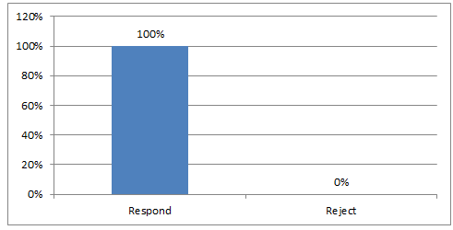
Figure 1: Research Response Rate

More than 50% of research questionnaire respondents are married. Furthermore than 50% of sample population contains male population.

4.3 Sample Profile

variable | Category | Frequency | Percentage
Gender | Male  Female | 58  42 | 58%  42%
Age | Less than 6 months  6 months – 12 months  12 months–24 months  24months –60 months  More than 60 months | 12  18  33  25  12 | 12%  18%  33%  25%  12%
Marital status | Married  Single | 69  31 | 69%  31%

Research questionnaire approach is used gather the research primary data from the 100 sample employees in the production department of the organization.

4.4 Research reliability testing

Table 1: Case processing summary
Case Processing Summary
 |  | N | %
Cases | Valid | 88 | 98
 | Excluded | 12 | 2
 | Total | 100 | 100
a. List wise deletion based on all variables in the procedure.
Cronbach’s alpha testing uses 100 samples, out of that 12 samples are excluded for the reliability testing due to the accuracy and completeness problem of research questionnaire form.

Table 2: Reliability statistics
Reliability Statistics
Cronbach's Alpha | Cronbach's Alpha Based on Standardized Items | N of Items
0.734 | 0.734 | 100

Cronbach’s alpha measures are as follows;

Table 3: Cronbach’s alpha
Cronbach’s alpha | Internal consistency
α ≥ 0.9 | Excellent
0.9 > α ≥ 0.8 | Good
0.8 > α ≥ 0.7 | Acceptable
0.7 > α ≥ 0.6 | Questionable
0.6 > α ≥ 0.5 | Poor
0.5 > α | Unacceptable

Since Cronbach alpha amount is 0.734, internal consistency of the organization is at an acceptable stage.

4.5 General research data analysis

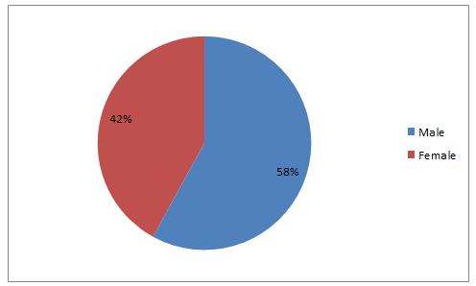
Figure 2: Gender analysis of the sample population
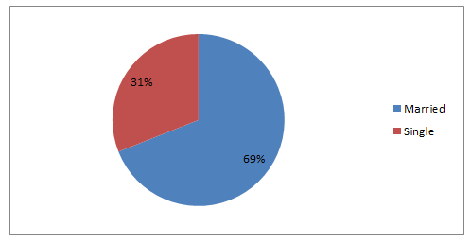
Figure 3: Marital Status of the sample population
More than 50% of research questionnaire respondents are married. Furthermore than 50% of sample population contains male population.

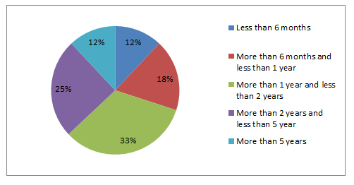
Figure 4: Working Experience of the Sample Population
When reviewing the working experience of research questionnaire participants, it is noted that most of the employees of research questionnaire participants have more than 1 year and less than 2 years working experience that is 33% from total sample population. Employees who have more than 5 years’ experience and employees who have less than 6 months experience are equal in number. While the second most number of employees have experience with in 2 to 5 years.

4.6 Independent Variable analysis

Research hypothesis I – Warehouse Management Practices

In gathering research primary data with respect to research hypothesis on the main concern on integration between production Management process and warehouse Management process in terms of implementing and executing The Lean Management practices. Most of the people responded that organization has not excess raw material inventory levels and it has been caused to increase the material holding cost and increase the location required to store the raw materials. Primary research data review highlights that 46% of the employees are disagree and 18% of employees are strongly disagree with the research question 04. While only 10% agreed on the research question.

Response | Participants | Percentage
Strongly agree | 2 | 2%
Agree | 8 | 8%
Neither agree nor disagree | 26 | 26%
Disagree | 46 | 46%
Strongly disagree | 18 | 18%
 | 100 | 100%

Table 04: Research Question 04 - Warehouse Management Practices
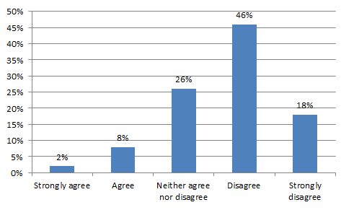
Figure 05: Research Question 04 - Warehouse Management Practices

In issuing raw material to the production process warehouse activities and function does not highly concern on real requirements of raw materials to the production process and it has been caused to increase the raw material wastages during the production process. With respect to the below interpretations, 12% of research questionnaire respondents are strongly agree and 34% of the employees are agree with the research question. Only 4% strongly disagrees with the research question 05.

Response | Participants | Percentage
Strongly agree | 12 | 12%
Agree | 34 | 34%
Neither agree nor disagree | 40 | 40%
Disagree | 10 | 10%
Strongly disagree | 4 | 4%
 | 100 | 100%

Table 05: Research Question 05 - Warehouse Management Practices

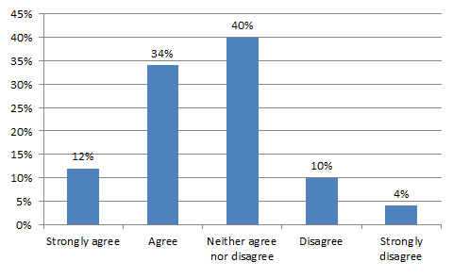
Figure 06: Research Question 05 - Warehouse Management Practices

Due to the lack of proper coordination between warehouse Management process and production manager process there are lots of delays in issue in the raw material to the production process and it has been recently to increase the number of production details in the production management process as well. In Planning and implementing lean management processes and practices organization should hire concern on how organization and operation management strategies in order to ensure proper integration and combination between warehouse Management process and production management process. Primary research data review indicates that 8% of employees are strongly agree, 14% of employees are agree, 48% of employees are neither agree nor disagree, 20% of employees are disagree and 10% of employees are strongly disagree with the research question 06.

Response | Participants | Percentage
Strongly agree | 8 | 8%
Agree | 14 | 14%
Neither agree nor disagree | 48 | 48%
Disagree | 20 | 20%
Strongly disagree | 10 | 10%
 | 100 | 100%

Table 06: Research Question 06 - Warehouse Management Practices

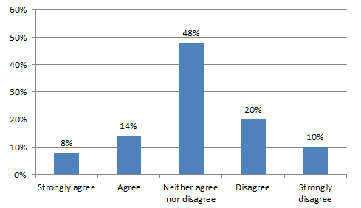
Figure 07: Research Question 06 - Warehouse Management Practices

Research hypothesis II – Supply chain management process

Most of the people in some population highlighted that there is no proper relationship management process between procurement management strategies and suppliers. Most of the people didn’t agree or disagree to the question while only 2% strongly agreed and 12% agreed on the research question 07. 30% Disagreed on it.
Response | Participants | Percentage
Strongly agree | 2 | 2%
Agree | 12 | 12%
Neither agree nor disagree | 38 | 38%
Disagree | 30 | 30%
Strongly disagree | 18 | 18%
 | 100 | 100%

Table 07: Research Question 07 - Supply chain management process

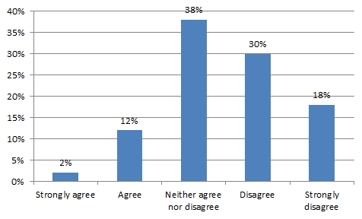
Figure 08: Research Question 07 - Supply chain management process

It is important to review the quality of the raw material when issuing the goods received note when receiving the purchase orders to the warehouses. In the organization there is no proper mechanism to evaluate the strengths and weakness of the suppliers to ensure the continuation of the procurement process. Primary research data review indicates that 2% of employees are strongly agree, 12% of employees are agree, 32% of employees are neither agree nor disagree, 42% of employees are disagree and 12% of employees are strongly disagree with the research question 08.
Response | Participants | Percentage
Strongly agree | 2 | 2%
Agree | 12 | 12%
Neither agree nor disagree | 32 | 32%
Disagree | 42 | 42%
Strongly disagree | 12 | 12%
 | 100 | 100%
Table 08: Research Question 08 - Supply chain management process

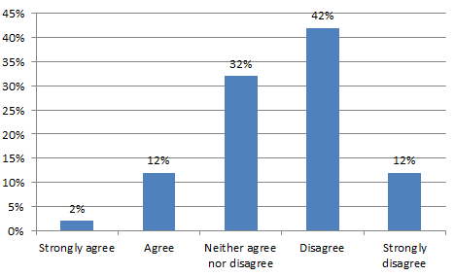
Figure 09: Research Question 08 - Supply chain management process
It is required to analyze organization has proper mechanism to evaluate the quality of raw materials when receiving to the warehouses. Due to lack of proper coordination and combination between supply chain management studies and warehouse management strategies organization cannot get the support of supply chain management strategies in order evaluate the quality of raw materials when receiving to warehouses. 40% of the people nether agree or disagree while only 4% strongly disagree. Agreed percentage was 34% and 12% strongly agreed on the research question 09.

Response | Participants | Percentage
Strongly agree | 12 | 12%
Agree | 34 | 34%
Neither agree nor disagree | 40 | 40%
Disagree | 10 | 10%
Strongly disagree | 4 | 4%
 | 100 | 100%

Table 09: Research Question 09 - Supply chain management process

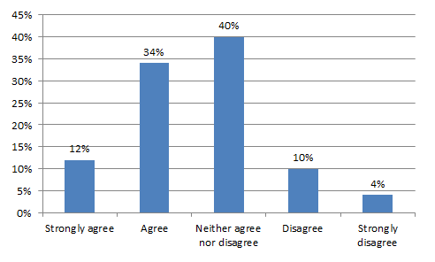
Figure 10: Research Question 09 - Supply chain management process

The second research hypothesis discussed about whether organization maintains the optimum inventory levels in the warehouses. Primary research data review indicates that 2% of employees are strongly agree, 4% of employees are agree, 36% of employees are neither agree nor disagree, 38% of employees are disagree and 20% of employees are strongly disagree with the research question 10.

Response | Participants | Percentage
Strongly agree | 2 | 2%
Agree | 4 | 4%
Neither agree nor disagree | 36 | 36%
Disagree | 38 | 38%
Strongly disagree | 20 | 20%
 | 100 | 100%

Table 10: Research Question 10 - Supply chain management process

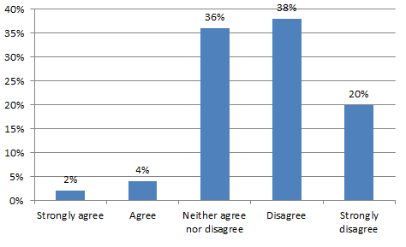

Figure 11: Research Question 10 - Supply chain management process

Research hypothesis III – Employee awareness

Organization does not listen to the suggestions and recommendations of the employees. Majority of the respondents were agreed which was 36% and 22% strongly agreed. While 8 % strongly disagreed and 16% disagreed on the research question 12.

Response | Participants | Percentage
Strongly agree | 22 | 22%
Agree | 36 | 36%
Neither agree not disagree | 18 | 18%
Disagree | 16 | 16%
Strongly disagree | 8 | 8%
 | 100 | 100%
Table 11: Research Question 11 - Supply chain management process

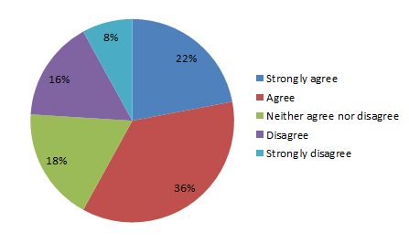
Figure 12: Research Question 11 - Supply chain management process

Employee understanding about importance and significance about the lean management practices is important to ensure the efficiency and effectiveness of established lean Management process. Primary research data review indicates that 28% of employees are strongly agree, 18% of employees are agree, 36% of employees are neither agree nor disagree, 12% of employees are disagree and 6% of employees are strongly disagree with the research question.

Response | Participants | Percentage
Strongly agree | 28 | 28%
Agree | 18 | 18%
Neither agree not disagree | 36 | 36%
Disagree | 12 | 12%
Strongly disagree | 6 | 6%
 | 100 | 100%

Table 12: Research Question 12 - Employee awareness

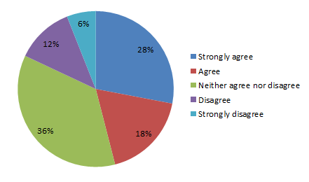
Figure 13: Research Question 12 - Employee awareness

Primary data review evident that current training and development process of the organization is not functioning properly to ensure that employees are aware on lean management process. Primary research data review indicates that 4% of employees are strongly agree, 12% of employees are agree, 46% of employees are neither agree nor disagree, 30% of employees are disagree and 8% of employees are strongly disagree with the research question 11.
Response | Participants | Percentage
Strongly agree | 4 | 4%
Agree | 12 | 12%
Neither agree nor disagree | 46 | 46%
Disagree | 30 | 30%
Strongly disagree | 8 | 8%
 | 100 | 100%
Table 14: Research Question 13 - Supply chain management process

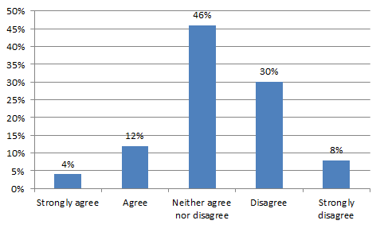
Figure 15: Research Question 13 - Supply chain management process

Research hypothesis IV – Management commitment

Primary data review evidence that management does not motivate the employees in developing and execute in the lean management practices within the organization. As a result of that organization has been failed to get the maximum contribution and commitment of the management of the organization in order to implement successful lean Management process. Primary research data review indicates that 16% of employees are strongly agreed, 28% of employees are agreed, 32% of employees are neither agree nor disagree, 12% of employees are disagreed and 12% of employees are strongly disagreed with the research question 14.
Response | Participants | Percentage
Strongly agree | 16 | 16%
Agree | 28 | 28%
Neither agree not disagree | 32 | 32%
Disagree | 12 | 12%
Strongly disagree | 12 | 12%
 | 100 | 100%

Table 15: Research Question 14 - Management commitment
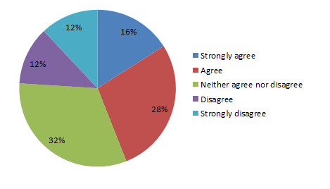
Figure 16: Research Question 14 - Management commitment

More than 35% of the employees of the organization emphasize that organization’s management people does not have comprehensive understanding over lean management practices within the organization.
Response | Participants | Percentage
Strongly agree | 10 | 11%
Agree | 13 | 15%
Neither agree not disagree | 32 | 36%
Disagree | 25 | 28%
Strongly disagree | 8 | 9%
 | 88 | 100%

Table 16: Research Question 16 - Management commitment5
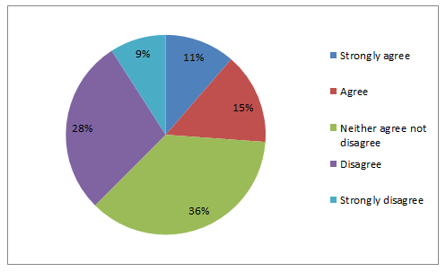
Figure 17: Research Question 15 - Management commitment

Research hypothesis V – Environmental review

Implementation of proper internal and external environmental reviewing process is important to understand the implications and consequences of changes in environmental factors and how those changes effects the strategies decisions over lean management process. Majority of the respondents were neither agreed or disagreed on the research question 15 which is 42%. 26% were agreed while 14% strongly agreed on it. Only 4% strongly disagreed on the research question.
Response | Participants | Percentage
Strongly agree | 14 | 14%
Agree | 26 | 26%
Neither agree not disagree | 42 | 42%
Disagree | 14 | 14%
Strongly disagree | 4 | 4%
 | 100 | 100%

Table 17: Research Question 16 - Environmental review
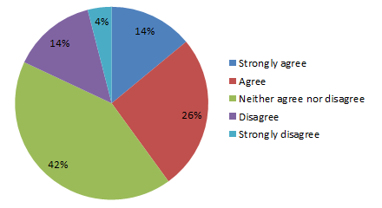
Figure 18: Research Question 16 - Environmental review

More than 50% of the employees of the organization highlight that organization does not evaluate the significance of external environmental implications in lean management strategies implementation process.
Response | Participants | Percentage
Strongly agree | 4 | 4%
Agree | 8 | 8%
Neither agree not disagree | 37 | 37%
Disagree | 33 | 33%
Strongly disagree | 18 | 18%
 | 100 | 100%

Table 18: Research Question 17 - Environmental review

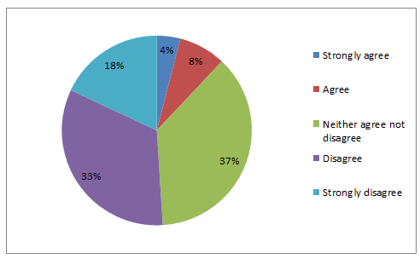
Table 18: Research Question 17 - Environmental review
It is important to conduct training and development programs in order to enhance awareness of Human Resource regarding the importance of lean management practices. However managers should be applied and executed within the normal cause of business activities. In this organization there was no proper training and development process to conduct the training programs to make the employees aware to ensure high level of understanding of interpretation and application of Lean Management Strategies and practices. It is important to communicate the changes in internal environment factors such as production process and operation management process to the Employees at right time. Current Change management strategies of the organization have not been capable of delivering the changes and its implication on existing business process to the Employees.
Management of the organization does not have proper statistical approach to get the maximum commitment and contribution of the employees to implement and execute the lean management Strategies and practices within the organization. As a result of that there is no proper combination between management level employees and operational level employees in terms of implementing lean Management process within the organization. In this organization managerial level employees have proper and adequate understanding about the importance of lean management practices and the problem is most of the management level employees do not know how to apply those strategy in practical scenario and how to get the commitment and contribution of the operation management level employees to ensure the success of lean Management process and practices.
Compare two operational level employees of the organization and management level employees in this organization who has high level of commitment and contribution to implement lean management practices within the organization and ensure the success of the business process used in the lean management practices and strategies. Lean management practices and strategy should be changed based on the changes and variances within the organization. In order to implement environmental changes based lean management practices there should be a proper environmental review mechanism and strategies within the organization. Primary data review highlights that organization does not change the lean management practices and other operation management strategies based on the changes of the internal environmental factors and external environmental factors. That means most of the Change Management Strategies and operation management strategies does not meet the modern business environmental requirements.
In addition to that there is no proper structural framework to evaluate the internal environmental strengths and weaknesses into wellbeing of the lean management system within the organization. However, there are few steps which were taken to consider the changes in external environment of the organization in order to plan and execute the Change Management Strategies and Operation Management strategies. Primary data review evident that organization does not have proper Lead Management practices to ensure the effectiveness and efficiency of the integration between function of management strategies of the organization. That means production Management process and warehouse Management process of the organization have not been integrated to ensure the proper combination between each and every function and managerial Strategies and practices to achieve the business goals and objectives.

4.4 Pearson’s correlation of coefficient analysis

 |  | Lean managements efficiency and effectiveness | Warehouse management process | Supply chain management strategies | Employee understanding | Management commitment | Environmental review
Lean managements efficiency and effectiveness
 | Pearson Correlation | 1 | 0.667 | 0.485 | 0.566 | 0.467 | 0.695
 | Sig. (2-tailed) |  | 0 | 0 | 0 | 0 | 0
 | N | 100 | 100 | 100 | 100 | 100 | 100
Warehouse management process | Pearson Correlation | 0.832 | 1 | 0.394 | 0.459 | 0.358 | 0.594
 | Sig. (2-tailed) | 0 |  | 0 | 0 | 0 | 0
 | N | 100 | 100 | 100 | 100 | 100 | 100
Supply chain management strategies | Pearson Correlation | 0.285 | 0.378 | 1 | 0.594 | 0.285 | 0.186
 | Sig. (2-tailed) | 0 | 0 |  | 0 | 0 | 0
 | N | 100 | 100 | 100 | 100 | 100 | 100
Employee understanding | Pearson Correlation | 0.484 | 0.704 | 0.443 | 1 | 0.405 | 0.727
 | Sig. (2-tailed) | 0 | 0 | 0 |  | 0 | 0
 | N | 100 | 100 | 100 | 100 | 100 | 100
Management commitment | Pearson Correlation | 0.174 | 0.389 | 0.594 | 0.488 | 1 | 0.454
 | Sig. (2-tailed) | 0 | 0 | 0 | 0 |  | 0
 | N | 100 | 100 | 100 | 100 | 100 | 100
Environmental review | Pearson Correlation | 0.270 | 0.423 | 0.475 | 0.467 | 0.165 | 1
 | Sig. (2-tailed) | 0 | 0 | 0 | 0 | 0
 | N | 100 | 100 | 100 | 100 | 100 | 100

Table 16: Pearson correlation of coefficient
As per the above table considerations of changes in external environmental factors is important the ensure the higher production process efficiency and effectiveness of the organization. In addition, on that procurement value stream is crucial to ensure the higher level of operational process efficiency and effectiveness of the organization.

4.5 Chi-Square method

Hypothesis I
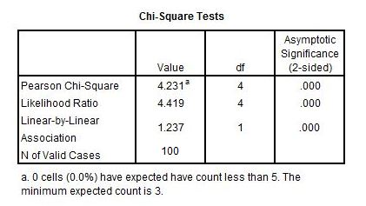
Accept null hypothesis (Pearson Chi Square value > Expected Value)
Hypothesis II
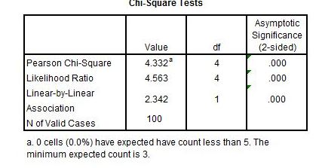
Accept null hypothesis (Pearson Chi Square value > Expected Value)
Hypothesis III
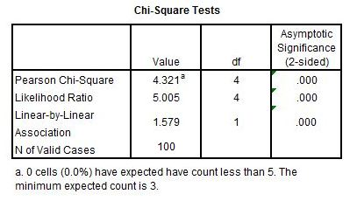
Accept null hypothesis (Pearson Chi Square value > Expected Value)

Hypothesis IV
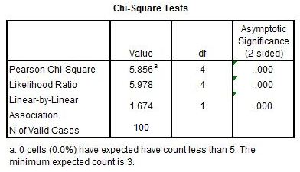
Accept null hypothesis (Pearson Chi Square value > Expected Value)

Hypothesis V
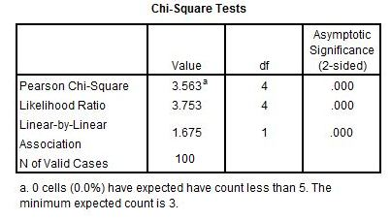
Accept null hypothesis (Pearson Chi Square value > Expected Value)

5.Research conclusion and Recommendations

5.1 Introduction

Research conclusion and recommendation chapter discusses the interpretations and implications of research data analyzing process to evaluate the relationship between research independent variables and dependent variables. In this chapter author discusses the key findings of the research, conclusion and recommendations of the research and further research areas.

5.2 Key Findings

The key findings of the research can be mentioned as ensuring higher efficiency and effectiveness of lean management practices of the organization, there should be a proper integration between warehouse management process and production management process of the organization. In addition to that it is required to integrate lean management practices with internal environmental review process and external environmental review process to update the lean management practices with respect to the environmental changes. In this organization lean Management process and warehouse Management process is acting as a separate Department without proper combination and integration between each functional department. To increase the efficiency of production process it is essential to have better communication and coordination between warehouse Management process and production management process.

5.3 Conclusion

To ensure the efficiency and effectiveness of Lean Management practices there should be maximum commitment and contribution from the employees to implement the most suitable and appropriate lean management practices. In this organization was no proper mechanism to obtain the maximum commitment and contribution of the employees to implement efficient and effective lean Management process to enhance the capabilities and competencies of the organization to develop the production goals and objective. As a result of that understanding about the importance and significance of the lean management practices of employees is at minimum level compare to the other business organizations in the industry.
Further the applicability of leadership management strategies that contribute to the management persons is considered as critical success factors in order to ensure an excellent of lean management system. Management of the organization should directly be involved in Planning and executing the lean Management process in organization in order to identify the issues and problems related to lean management practices and integrate the lean Management process with other functional strategies. However, in this organization there is no proper structural framework to obtain the commitment and support of the leaders in the organization in terms of developing and identifying the issues and problems of lean management system. Lean management Strategies and lean management practices of the organization should be updated with respect to the changes in internal environment factors and external environmental factors. Internal environmental preview involve in identifying strategic capabilities of the organization to implement most effective and efficient lean Management process within the organization. External environmental review is important to ensure how it and environmental factors such as political environment, social environment, technological environment, economic environment will impact to the decisions and applications of lean Management process of the organization. In this organization there is no proper combination and integration between lean management system and environmental screening mechanism to identify and change the lean management practices based on the fluctuations and variance of internal and external environmental factors.
Implementation of lean management practices in points with ensuring proper integration and combination between function and management processes of the organization. It is important to ensure proper integration between production Management process and warehouse Management process to acquire required raw materials to the production process within right time to reduce the delays in production process. In this organization lean Management process and warehouse Management process is acting as separate departments without proper combination and integration between each functional department. To increase the efficiency of production process it is essential to have better communication and coordination between warehouse Management process and production management process. Further supply chain management strategies of the organization should be integrated and combined with management system to take the procurement decision at right time in order to maintain the minimum order level and optimize inventory position within the warehouses. In this organization there is no structural combination and coordination between supply chain management process and warehouse Management process as a result of that organization has excess inventory levels in the warehouse and it will increase the material holding cost and material maintenance cost within the warehouse.
The core objective of implementing and executing lean Management process is to eliminate non value added activities in Operation processes of the organization. For example, implementation of Lean Management process involved in identifying non value adding activities in production Management process and eliminates those activities to reduce the production cost and deliver the final product at lower price and strategy. Primary data review shows that most of the processes of the organization have no value-added activities which increase the operational cost of each functional department. Over the period of time management has not taken a single appropriate action to identify non value-added activities and take appropriate statistical approach. Implementation of lean Management process not a simple task. Organization has to invest financial and non-financial resources to ensure the effectiveness and efficiency of our lean management practices. In addition to that it is required to invest in modern technological Framework to ensure accuracy and completeness of the results and outcome in lean management system in the organization. In this organization there is no current and future plan to allocate financial and non-financial resources to implement lean management practices and enhance the accuracy and completeness of outcome in lean management system which can be taken to strategic decisions in Management process of the organization.
Employee understanding of the importance and significance of lean Management process is at minimum level compared to other competitive business organizations. further top management people in the organization does not have proper understanding over how lean Management process is operating and how business organization can take the benefits from implementation of lean management system within the organization. In addition to that most of the people in this organization have been stuck with the busy work schedule and there's no room and time to learn about lean management practices and how those practice can be used to reduce the time consumption for day to day working activities. Lean manufacturing system is an important system for manufacturing business organizations to integrate overall functional activities of the organization. It will help to ensure the operational efficiency and effectiveness of the business operations to eliminate non-value adding activities of operation management process. The research study evaluates how lean management practices can be used to reduce the risk of production delays. Lean manufacturing system increases the long-term operation performance and the organization’s value. It will be resulting in increasing the customer base as a result of touching new market segments through the products manufacturing process in the organization. The main challenge is employee resistance to change. Most of the employees are reluctant to change from traditional methods to new methods in manufacturing processes.

5.4 Recommendations

Lean management process is linked with the production process of manufacturing organization. It ensures the proper coordination and integration among each operational function of manufacturing organization. Most of the manufacturing business organizations aims to increase the productivity of the production process using lean management related strategies and practices. Lean Manufacturing is a systematic approach for identifying and eliminating wastes (non-value adding activities) through continuous improvement by conveying the product at the pull of the customer in pursuit of production. It is an important system to manufacturing business organizations to integrate the overall functional activities of the organization. It will help to ensure the operational efficiency and effectiveness of the business operations in order to eliminate non-value adding activities of operation management process. The research study evaluates how lean management practices can be used to reduce the risk of production delays.
Based on the discussion on lean management practices of the organization it is recommended to implement and execute training and development program which focuses on employees and management of the organization to communicate and make aware of those target audience with respect to importance of lean management practices and Lean Management processes of the organization. It will help to obtain the maximum commitment and contribution of the employees in terms of developing effective and efficient lean management practices and strategies within the organization to attend operational management goals and objectives of the organization and use those advantages to achieve corporate level objectives.
As discussed above current environmental screening approaches and mechanism of the organization is not effectively functioning to capture the each and every changes and variances in internal environment and external environment of the organization. It is recommended to review the applicability and suitability of the current environmental review Strategies and practices of the organization and take appropriate actions to implement updated external environmental Strategies and internal environment strategies to review those changes with respect to the functional goals and objectives and corporate governance objectives of the organization. It is recommended to review the warehouse Management process of the organization to integrate the warehouse Management process and production management process of the organization. To update the warehouse management Strategies and practices of the organization it is recommended to implement just in time inventory management system to reduce the time consumption on Inventory Management and inventory maintenance of the organization.
In determining the most suitable organization structure for Research organization in expanding the business operations to the China market, organization should focus on different types of organization structures. There are different organization structures such as functional organization structure, centralized organization structured, product-based organization structure, decentralized organization structure, geographical based organization structure and matrix organization structure. In the Research organization context author recommends to uses the matrix organization structure in expanding the operations to the China market. The main reason for that recommendation is, it will help to integrate and coordinate each functional departments of the organization.
When discusses the most appropriate organization culture for the Research organization in expanding the business operations in China, organization can practice four types of organization culture such as power culture, role culture, task culture and person culture. However, it is recommended to adhere on task organization culture for Research organization. Because task organization culture is more operation oriented and it ensures the effectiveness and efficiency of the operation in the organization.

Research organization should have four main functional departments such as finance department, human resource department, product management department and sales and marketing department. Finance department should involve in formulating and executing the finance management strategies while human resource department manages the human resource of the organization. Further sales and marketing department should execute the necessary actions to enhance the customer base and product management department should involve in manufacturing a better product to the market. Organization requires both tangible and intangible resources to operate the business activities. Under tangible resource, organization should focus on the resources such as finance resources, physical resource and human resource. The main intangible resource is time resource. Finance resource compromises the adequate finance to tune the business activities. In addition to that it discusses how organization should invest in potential investment activities. Further human resource contains the competent and skillful labor force to execute the operational activities of the organization. In addition to that physical resource discusses the adequacy and quality of the facilities such as office space, furniture, transportations, machineries etc.
In addition to that time is the most important intangible resource to the organization. Therefore, organization should have proper plan and mechanism to ensure the all the functions and tasks of the organization are operating according to the predefined time frame. Lean manufacturing system is used in most of the manufacturing organizations. The main objective of implementing lean manufacturing is to enhance the operational efficiency and effectiveness of the production process and other operational functions while reducing waste & cost in the organization. Current business world is highly competitive, and all the business organizations aim to ensure a high level of operational efficiency to meet the competition. In this research, author mainly discusses the implementation of lean management system in Sri Lankan apparel industry meet the production deadlines and production requirements of the apparel industry. Further this research discusses how the organization should develop lean management strategies in order to integrate other operational functions with lean management system. In this research author discusses theoretical interpretations of lean manufacturing system and how lean manufacturing system is practicing and applying in real work scenarios. Lean management Strategies and lean management practices of the organization should be updated with respect to the changes in internal environment factors and external environmental factors. Internal environmental preview involves in identifying strategic capabilities of the organization to implement most effective and efficient lean Management process within the organization of research organizations to achieve operation management goals and objectives.

5.5Areas for Further research

Further research areas aim to expand the scope of the research by analyzing the applications of lean management practices and how lean management efficiency and effectiveness should be enhanced. It is expected to conduct the research for pharmaceutical industry and food manufacturing industry in Sri Lanka. Further it is expected to expand the sample size of research to ensure a high level of accuracy and reliability of research findings.

5.5 Limitations

Limited period of time to complete the overall research activities is the main limitation of the research. In addition to that researcher has to find the software platforms to analyze the research data and it has to allocate more financial resource to acquire relevant research data analyzing software.

References

Anand, K., R. Anupindi, and Y. Bassok. (2008). Strategic Inventories in Vertical Contracts. Management Science 54 (10): 1792–1804.

Bahia, K. and Nantel, J. (2000) A reliable and valid measurement scale for the perceived service quality of banks, Journal of Bank Marketing, 18(2), pp. 84-91.
Barnes, D. (2008), Operations Management: An International Perspective, Thomson Learning, London.

Borghesi, A. and Gaudenzi. (2013) Risk Management, How to assess, transfer and communicate critical risks. 2nded. Italy: Spiner Italia.
Caro, F., and J. Gallien.(2007). Dynamic assortment with demand learning for seasonal consumer goods. Management Science, 53 (2): 276–292.

Heizer, J., Render B. and Rajashekhar, J. (2013) Operations Management. 9th ed. India: Dorling Kindersley India Private Limited.

Horns, C. and Rudolf, M. (2011) Service quality in the private banking business, Journal of Financial Markets and Portfolio Management, 25 (2), pp.173-195.
Hopkins, M. (2003) The Planetary Bargain – CSR Matters, 1st ed. London: Earthscan Publishers.
Johnson, R & Clark, G. (2008), Service Operations Management: Improving Service Delivery, 3rd edn, Pearson Education, Harlow.

Ivanov A., (2009), Using Prediction Markets to Harness Collective Wisdom for Forecasting, Journal of Business Forecasting, Fall, pp. 9-14.

Martin,P. and Tate, K. (2001), Getting started in Project Management. 1st ed. New York: John Wiley & Sons Inc.

Patterson, A. (2005) Information Systems. 1st ed. Scotland: Learning and Teaching Scotland.
Perry, B. (2009) Enterprise operations. 1sted. New Delhi: Elsevier India Private Limited.
Richards, J. (2012) Total Quality Management, Journal of Business Management and Strategy, 3(2), pp. 36-42.
Sangeetha, J. and Mahalingam, S. (2011) Service quality models in banking, Journal of Islamic and Middle Eastern Finance and Management, 4(1), pp.83-103.
Shahram, T. (2008) Lean manufacturing performance in China, Journal of Manufacturing Technology Management, 19(2), pp. 217-234.
Slack. N., Jones, A.B. and Johnston,R (2013) Operation Management. 7th ed. United Kingdom: Pearson Education Limited.
Stoner, F., Freeman, E., and Gilbert, R. (2007) Management.6thed. New Delhi: Prentice hall of India (Pvt) Ltd.
Svensson G. (2005). Leadership Performance in TQM: A Contingency Approach. The TQM Magazine. 17 (6) 527-536.

Teh P.L., et al. (2009). Does Total Quality Management Reduce Employees Role Conflict? Industrial Management and Data Systems. 109 (8) 1118-1136.

Ulu, C., D. Honhon, and A. Alptekino.(2012). Learning consumer tastes through dynamic assortments. Operations Research, 60 (4): 833–849.

Vittal, A., &Shivraj, K. (2008). Role of IT and KM in improving project management performance. VINE, 38 (3), 357 – 369.

Wang, T., A. Atasu, and M. Kurtulu.(2012). A multi ordering newsvendor model with dynamic forecast evolution. Manufacturing & Service Operations Management, 14 (3): 472–484.

Adams, S. J. (2000). Today's safety professional: Manager or engineer. Professional Safety, 45(6), 24−27.
Allon, G., and J. A. van Mieghem. (2010). Global Dual Sourcing: Tailored Base-Surge Allocation to Near-and Offshore Production. Management Science, 56 (1): 110–124
Barnes, D. (2008), Operations Management: An International Perspective, Thomson Learning, London.
Borghesi, A. and Gaudenzi. (2013) Risk Management, How to assess, transfer and communicate critical risks. 2nded. Italy: Spiner Italia.
Caro, F., and J. Gallien.(2007). Dynamic assortment with demand learning for seasonal consumer goods. Management Science, 53 (2): 276–292.
Chase, R. B., Jacobs, F. R., &Aquilano, N. J.(2007). Operations management for competitive advantage (11th ed.). New York: McGraw-Hill Irwin.
Chen, I. J., &Paulraj, A. (2004). Towards a theory of Production Planning: the constructs and measurements. Journal of Operations Management, 22: 119-150.
Cooper, M. C., Lambert, D. M., & Pagh, J. D. (1997). Production Planning: More than a new name for Logistics. The International Journal of Logistics Management, 8 (1): 1-14.
Ford, D., Gadde, L.-E., Ha kansson, H. and Snehota, I. (2003), Managing Business Relationships, 2nd ed., Wiley, Chichester.
Gebauer H, Kickuth M, Friedli T (2009). Lean Management Practices in the Pharmaceutical Industry. International Journal of Services and Operations Management. 5(4): 463-481.
Giunipero, L., Handfield, R.B. and Eltantawy, R. (2006), “Supply management’s evolution: key skill sets for the supply manager of the future”, International Journal of Operations & Production Management, Vol. 26 No. 7, pp. 822-44.
Heizer, J., Render B. and Rajashekhar, J. (2013) Operations Management. 9th ed. India: Dorling Kindersley India Private Limited.
Hopkin, S. P. (2013) Risk Management. 1st ed. United State: Kogan Page Limited.
Martin,P. and Tate, K. (2001), Getting started in Project Management. 1st ed. New York: John Wiley & Sons Inc.
Mentzer, J. T., DeWitt, W.,Kleeber, J.S., Min, S., Nix,N.W., Smith, C.D., & Zacharia, Z.G. (2001). Defining Production Planning. Journal of Business Logistics, 22: 1-25.
Patterson, A. (2005) Information Systems. 1st ed. Scotland: Learning and Teaching Scotland.
Perry, B. (2009) Enterprise operations. 1sted. New Delhi: Elsevier India Private Limited.
Ramayah T., et al.(2011).Market Orientation, Service Quality and Organizational Performance in Service Organizations in Malaysia. Asia-Pacific Journal of Business Administration. 3 (1) 8-27.

SarathyP.S.(2013).TQM Practice in Real-Estate Industry Using AHP. Quality Quantity. 47; 2049-2063.
Shah R, and Ward P T (2003). Lean manufacturing: Context, Practice Bundles, and Performance. Journal of Operations Management. 21: 129–149.
Slack. N., Jones, A.B. and Johnston,R (2013) Operation Management. 7th ed. United Kingdom: Pearson Education Limited.
Ulu, C., D. Honhon, and A. Alptekino.(2012). Learning consumer tastes through dynamic assortments. Operations Research, 60 (4): 833–849.

Wang, T., A. Atasu, and M. Kurtulu.(2012). A multi ordering newsvendor model with dynamic forecast evolution. Manufacturing & Service Operations Management, 14 (3): 472–484.

Appendix

Survey Questionnaire

  - General Information

- Gender details
Male
Female

- Marital status
Married
Single

- Working experience in apparel industry
Less than 6 months
More than 6 months and less than 1 year
More than 1 year and less than 2 years
More than 2 years and less than 5 year
More than 5 years

Research hypothesis analysis

Integration between inventory management and production management processes

04. Warehouses have excess fabric material inventories.
Highly agree with the research question
Agree with the research question
Neutral with the research questions
Disagree with the research question
Highly disagree with the research question

- Warehouse issues the fabric materials based on the production requirements of the production flow.
Highly agree with the research question
Agree with the research question
Neutral with the research questions
Disagree with the research question
Highly disagree with the research question

- There are delays in receiving the fabric materials from warehouses to production flow.
Highly agree with the research question
Agree with the research question
Neutral with the research questions
Disagree with the research question
Highly disagree with the research question

Integration between supply chain management and production management processes
- Supply chain management practices ensure the strong business relationship with suppliers
Highly agree with the research question
Agree with the research question
Neutral with the research questions
Disagree with the research question
Highly disagree with the research question

- Supply chain management strategies review the supplier capacity and strengths
Highly agree with the research question
Agree with the research question
Neutral with the research questions
Disagree with the research question
Highly disagree with the research question

- Organization has proper mechanism the ensure the material quality at the point of goods receiving
Highly agree with the research question
Agree with the research question
Neutral with the research questions
Disagree with the research question
Highly disagree with the research question

- Supply chain management strategies capable of holding optimum inventory levels.
Highly agree with the research question
Agree with the research question
Neutral with the research questions
Disagree with the research question
Highly disagree with the research question

Employees’ understanding on lean management process and its practices

- Organization listens to employees’ suggestions in implementing lean management strategies
Highly agree with the research question
Agree with the research question
Neutral with the research questions
Disagree with the research question
Highly disagree with the research question

- Employees have comprehensive understanding on lean management process
Highly agree with the research question
Agree with the research question
Neutral with the research questions
Disagree with the research question
Highly disagree with the research question

- Organization conducts training programs to enhance the employee awareness on lean management
Highly agree with the research question
Agree with the research question
Neutral with the research questions
Disagree with the research question
Highly disagree with the research question

Management commitment to implement and execute the lean management process

- Management induces and motivates the employees towards lean management process.
Highly agree with the research question
Agree with the research question
Neutral with the research questions
Disagree with the research question
Highly disagree with the research question

- Management level personal has comprehensive understanding on lean management process
Highly agree with the research question
Agree with the research question
Neutral with the research questions
Disagree with the research question
Highly disagree with the research question

Integration between lean management and environmental screening process

16. Organization changes the lean management strategies based on the changes in environmental factors.
Highly agree with the research question
Agree with the research question
Neutral with the research questions
Disagree with the research question
Highly disagree with the research question

- Organization evaluates the significance of external environmental factors in implementing and executing the lean management strategies.
Highly agree with the research question
Agree with the research question
Neutral with the research questions
Disagree with the research question
Highly disagree with the research question

