Al Hayat Hotel Wireless Coverage
Presented by (Student Name)
Introduction
Al Hayat Hotel offers accommodation services to guests who have business meetings and other people who intend to have conduct leisure activities. In every company, internet access and connectivity to the world is becoming a necessity. Companies' strategies to counter the stiff competition in the current world of computing and the growing technology are among the strategies deployed by companies. Al Hayat Hotel Management is, therefore, determined to provide a network to serve the guests for entertainment purposes and research where applicable as well as connectivity to any other occupant of the hotel at a given time. The needs of Al-Hayat to provide a seamless network connection for all of its customers using the facility calls for the design and implementation of the best network design that will meet the hotel's goals and objectives. Working in teams, every team member has his/her specific network design. These network designs provide different user experiences, which can be analysed to check in the network's effectiveness in terms of its design, performance, and consideration for innovative ideas. The following paper is a report mentioning all of these network designs and implementations and provides recommendations for the opening of creative ideas.
Requirements
Al Hayat Hotel is considered to have ten floors. To set up an efficient and reliable network, the following devices are required;
- Twelve wireless routers – each floor will have a wireless router from the ground floor to the 10th floor. One router (core layer of the topology) will be used to connect the entire network topology of the company to the internet.
- 2 multilayer switches – these two switches will be connected directly to the router that is linked to the internet. The switches are responsible for distributing the internet to the floors building whereby one switch will serve six floors, and the other one will serve five floors. The reason for preferring the multilayer switches from the ordinary ones is that they are capable of performing similar tasks as routers such as packet filtering. They also have a high speed of data transmission [4]. These two devices operate at the distribution layer of the topology
- 2 computers – used to establish wireless connectivity.
- At least two wireless portable devices to test the wireless connectivity of individual routers on all the floors.
- CAT 6 LAN Cables to interconnect the routers from each floor to the appropriate switches.
- Enough power access points for switches, routers, and computers.
The Network Design.
The network topology chosen for Al Hayat Hotel has a combination of two topologies; such a topology is usually referred to as Hybrid Network Topology [1]. It comprises of the star topology at the core layer and the tree topology at the distribution layer.
Star Topology
All the devices in this type of topology ate directly connected to the central node [2].
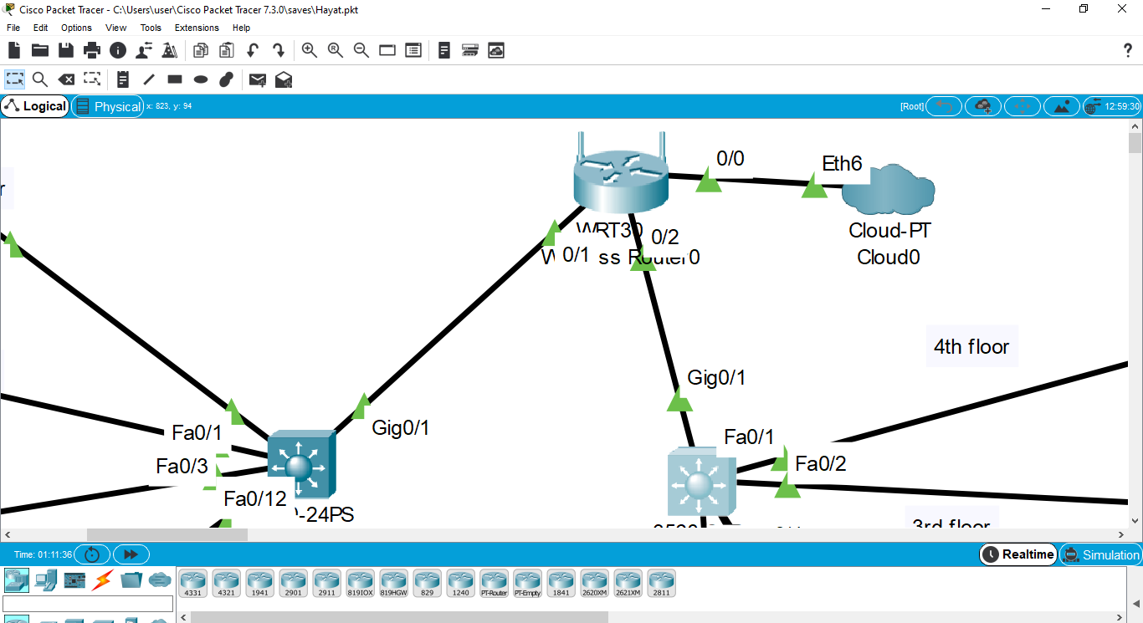
The core layer of our topology appears as in the diagram above.
Tree Topology
It is also known as hierarchical topology and has combined features of both the star and bus topologies [3]. It has groups of star networks interconnected via a bus backbone. This topology is exhibited at the distribution to the access layer of our network.
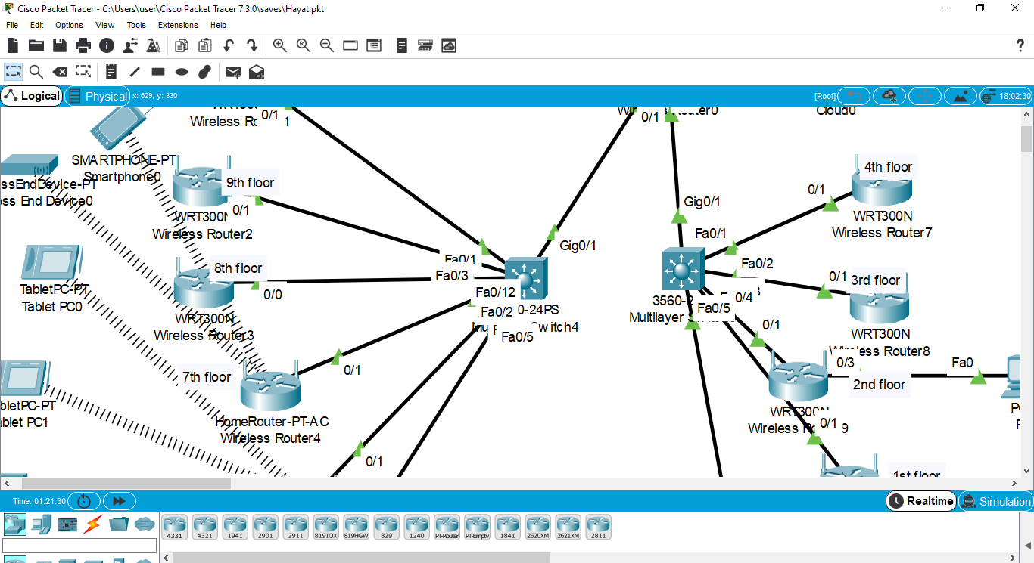
The distribution and access layers of our network are shown in the above diagram.
Advantages of the Topology
- Ease of troubleshooting.
- A faulty node does not affect the entire network.
- Ease of network expansion if the need arises.
- Ease of installation of new segments.
Disadvantages of the Topology.
- The requirement of long cables to connect individual node in a star topology
- In case the central node comes down, the entire network is shut.
- The expertise of a higher level is required to configure the network.
- Difficulty in maintenance for more extensive networks.
IP Addressing
The network has been found suitable in its wireless state for most of the guests and other visiting occupants of the hotel because most of them carry their portable devices only. A few nodes of wired devices in offices will be required to connect their computers for the staff members. The DHCP Request has been used to automatically assign the IP addresses to the various nodes of the network.
If a guest happens to be on a given floor, they can connect to the network, the router in that floor will establish a connection by assigning the device an IP address using the DHCP request. The gust will then use the default login credentials to the network (admin for both username and password). The system admin can change these credentials.
Connectivity
To test connectivity of the network, add a wireless device then use the DHCP request to assign the IP address. After the IP address is assigned, run the command ping (the assigned default gateway) from the new device. If th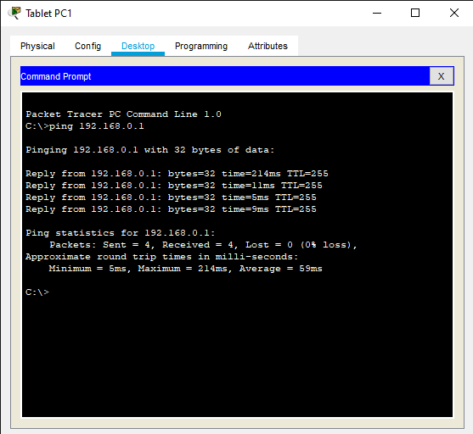e connection was successful the ping command output should be as follows;
Conclusion
The Al Hayat Hotel network has been well designed to suit all the network requirements of the company. The network can adopt changes in technology, can be easily expanded, and also compactible to upcoming software. The issue of security has also been addressed during the set-up of the topology.

References
[1] Arora, N., Zhang, H., Lumezanu, C., Rhee, J., Jiang, G., & Lu, H. U.S. Patent No. 9,450,823. Washington, DC: U.S. Patent and Trademark Office. (2016).
[2] Bisht, N., & Singh, S. Analytical study of different network topologies. International Research Journal of Engineering and Technology (IRJET), 2(01), 88-90. (2015).
[3] Chen, Y., Wu, J., & Ji, B. Virtual network function deployment in tree-structured networks. In 2018 IEEE 26th International Conference on Network Protocols (ICNP) (pp. 132-142). IEEE. (2018).
[4] Varvello, M., Laufer, R., Zhang, F., & Lakshman, T. V. Multilayer packet classification with graphics processing units. IEEE/ACM Transactions on Networking, 24(5), 2728-2741. (2015).

