Introduction
Uber Technologies Inc. Uber is a tech startup that provides ride sharing services by facilitating a connection between independent contractor’s drivers and riders with the use of an app. Uber has expanded its operations to 58 countries around the world and is valued at around $41 billion. Because its services costs less than taking a traditional taxi, in the few years it has been in business Uber and similar ride sharing services have upended the taxi industry. The company has experienced resounding success and is looking toward expansion both internationally and within the United States. However, Uber’s rapid success is creating challenges in the form of legal and regulatory, social, and technical obstacles. The taxi industry, for instance, is arguing that Uber has an unfair advantage because it does not face the same licensing requirements as they do. Others accuse Uber of not vetting their drivers, creating potentially unsafe situations. An accusation of rape in India has brought this issue of safety to the forefront. Some major cities are banning ride sharing services like Uber because of these various concerns. Additionally, Uber has faced various lawsuits, including a lawsuit filed against them by its independent contractors. Its presence in the market has influenced lawmakers to draft new regulations to govern this “app-driven” ride sharing system. Legislation can often hinder a company’s expansion opportunities because of the resources it must expend to comply with regulatory requirements.
Background
In 2009 Travis Kalanick and Garrett Camp developed a smartphone application to connect driver’s for-hire with people needing rides to a destination in their city. This innovative service was originally founded as Uber Cab Inc., a privately held company. It was renamed Uber Technologies, Inc. in 2010. Co-founders Kalanick and Camp designed the mobile-app for iPhone and Android smartphones, enabling customers to get an estimated time of arrival from the driver on their smartphone with the use of an integrated GPS system. Since launching in Australia in October 2012, Uber has offered an additional transportation option and choice for consumers in the point-to-point transportation market. Over 10 million rides have been completed across Australia on its low-cost ridesharing option, uberX, leading to a range of benefits for its users. Uber operates a variety of its services in Australia, including uberX, UberBLACK, UberSUV, UberLUX and UberTAXI. Each varies in price and standard of delivery, although the basic premise of booking a ride through their smartphone application remains the same. In Australia, Uber is the main provider of ridesharing services, primarily operating its Uber X and Uber BLACK services in Australian cities. However, recent times have seen competitors more closely aligned with Uber’s premium hire car service, Uber Black, enter the market. Ride Boom, an Australian application, began offering hire car services as of 10 September 2015. Uber Australia is located in Sydney, New South Wales, and Australia is part of Transportation Services Sector Industry. UBER AUSTRALIA has 269 total employees across all of its locations and generates $114.78 million in sales USD. There are 183 companies under Uber Australia corporate family.

Business Process Analytical Plan
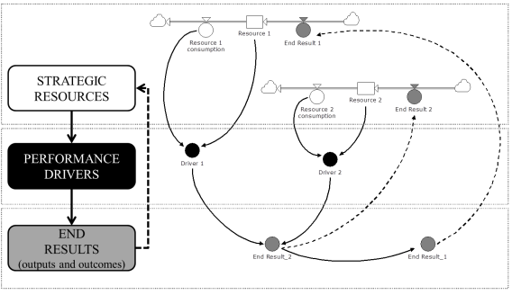
In this section, we present the dynamic performance management (DPM) chart applied for this case study. It is rather a schematic diagram, and it is meant for fostering insights about the business system structure and provides a basis for our next step where we introduce a system dynamics quantitative model.
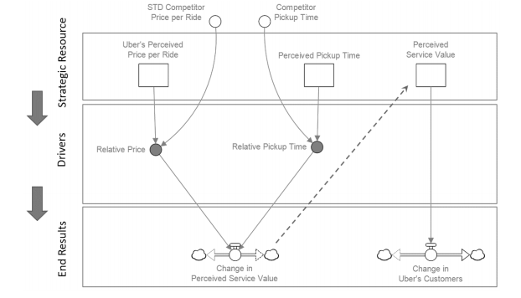
Uber’s customers are based on our assumption that people who are using the application consider two factors when they decide to choose Uber’s ride-hailing service among others. Uber’s current commission percentage that competitor. If there’s a huge gap between the two, either one of them attracts more driverpartners than the other. Bonus spending is classified as a strategic resource. We have done so based on two reasons. One is that in our model we could not find any financial data. However, it was necessary to incorporate bonus spending as one of the factors affecting the number of new drivers into Uber (Moon, 2015). Bonus spending is a broad term, related to available financial resources to attract additional drivers, and includes car leasing loans, performance-based bonuses provided, etc.
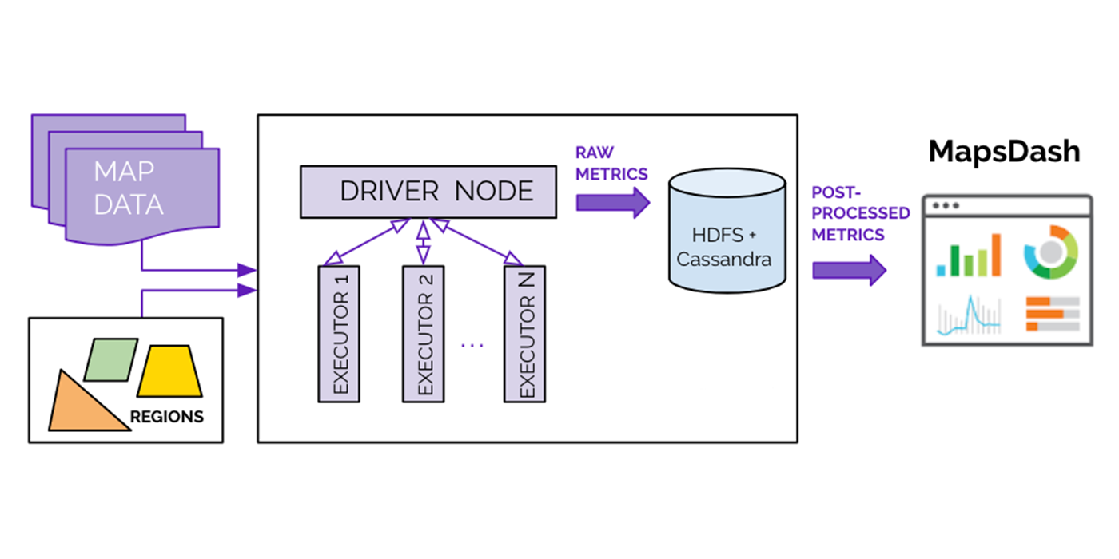
On the surface, Uber’s ridesharing technology may seem simple: a user requests a ride from the app, and a driver arrives to take them to their destination. Behind the scenes, however, a giant infrastructure consisting of thousands of services and terabytes of data supports each and every trip on the platform. At Uber the quality of our map data and map services is invaluable to delivering a great user experience. To accomplish this, maps must reflect geographic reality as closely as possible. The geospatial data generated by each of the millions of trips taken daily makes this possible, helping us refine and update our maps to achieve the highest quality. In this article, we define our map regions and show how we compute map quality metrics.

The Uber Map Model
Maps are intuitively defined by their purpose. A map orients us in space, letting us see where we are in the world. With a map, we can also navigate from where we are to where we want to go.
The Uber Map Model is a data structure made up of features and attributes. From the perspective of determining map quality, we define a map as a collection of map features, from man-made places like road segments, junctions, and buildings to natural features such as mountains, lakes, and oceans. Further, for Uber-specific use cases, we include access points, which specify allowed or preferred pick-up and drop-off locations for a certain address point, as map features. For example, access points at the San Francisco International Airport include a set of terminals, gates, and airport-determined gathering spots. Finally, each map feature has a set of attributes that fully describe it. For example, a road segment’s attributes include geometry, length, name, road class local road highway, and usage road bike path. Uber uses map data from a variety of third-party map providers, with a goal to enable a great Uber experience to our users. To ensure high quality or these maps, we utilize an iterative process of analyzing map data, identifying map defects, and fixing them. This creates a positive feedback loop for improving the maps.
Trace Coverage: A comparative coverage metric, trace coverage identifies missing road segments or incorrect road geometry. The computation uses two inputs: map data under testing and historic GPS traces of all Uber rides taken over a certain period of time. We overlay those GPS traces onto the map, comparing and matching them with road segments. If we find GPS traces where no road is shown, we can infer that our map is missing a road segment and take steps to fix the deficiency
Routing evaluation: Another critical metric of map quality, evaluating routes lets us identify incorrect turn restrictions and road directionality on our maps. Here, we compare the routes our navigation algorithm suggests for drivers with the actual routes they choose to take. If there is a sustained discrepancy between the suggested and actual routes, we investigate for potential map defects. Figure 3, below, shows an example of a large discrepancy between the suggested and actual routes. Our consequent comparison revealed incorrectly modeled turn restrictions on road segments that made it impossible to use the suggested route.
Preferred access point accuracy: Pick-up points are an extremely important metric to the rider experience, especially at large venues such as airports and stadiums. For this metric, we compute the distance of an address or place’s location, from all actual pick-up and drop-off points used by drivers. We then set the closest actual location to be the preferred access point for the said location pin. When a rider requests the location indicated by the map pin, the map guides the driver to the preferred access point. We continually compute this metric with the latest actual pick-up and drop-off locations to ensure freshness and accuracy of the suggested preferred access points.
Conclusion:
This analysis of the burgeoning Uber phenomenon was undertaken with the objective of gaining fruitful insights from a managerial perspective. Theories and frameworks are a useful and valuable resource, but they need to be constantly tested and validated by the ultimate judgment of the marketplace. So, while some principles might be broadly applicable to a large number of scenarios, it is only worthwhile to acknowledge that the capability of the departing from these guidelines may represent an invaluable resource. Good managers need to understand the what kind of strategies best suit the environment in which they operate, and Uber is the excellent example Uber firstly set its priority on the creation and the nurturing of its platform environment. Conscious that the real value of its platform was not laying in the technology behind it, Aside from the increasing menace of competitors, regulatory issues still represent the biggest concern for the company. In the end, Uber will have to come to terms with it.
References
References Belvedere, M.J. (2016). Uber CEO Travis Kalanick takes stand against critics who want IPO. Retrieved from CNBC.com: http://www.cnbc.com/2016/04/27/arianahuffington-to-join-ride-hailing-service-ubers-board-of-directors.html
Benenson Strategy Group (2014).The Driver Roadmap. Retrieved from: https://newsroom.uber.com/wp-content/uploads/2015/01/BSG_Uber_Report.pdf
Blystone, D. (2015). The Story of Uber. Retrieved from Investopedia.com: http://www.investopedia.com/articles/personal-finance/111015/story-uber.asp
Australian Broadcasting Corporation 2016, ‘These are the states and territories where Uber is (and isn’t) legal’, ABC News Online, 11 August, viewed 20 September 2017, http://www.abc.net.au/news/2016-08-11/where-is-uber-legal-in-australia/7719822
Australian Bureau of Statistics 2009, Patterns in work: Australian social trends, cat. no. 4102.0, ABS, Canberra.
Australian Council of Trade Unions 2012, Lives on hold: unlocking the potential of Australia’s workforce, Independent Inquiry into Insecure Work, Melbourne, viewed 1 September 2017, https://www.actu.org.au/media/349417/lives_on_hold.pdf

